A
Project Report On
“Development of an Intelligent Human-Guided Robot for personalized and interactive Educational Environments”
Submitted to
CHAITANYA BHARATHI INSTITUTE OF TECHNOLOGY

(Affiliated to Jawaharlal Nehru Technological University, Anantapuram)

In partial fulfillment of the requirements for the award of the degree of

BACHELOR OF TECHNOLOGY
In

ELECTRONICS AND COMMUNICATION ENGINEERING

Submitted By
Chaviti Venkata Sai Sree Harini 232P5A0405
Vanipenta Nanditha 222P1A04E6
Meer Abbasi Begum 232P5A0417
Sudha Lava Kumar Reddy 222P1A04C8
Vusa Hemanth Kumar 222P1A04F2
Under The Guidance of
Dr. SHAIK BAJIDVALI M.Tech., Ph. D
Professor, Dept. of ECE.



DEPARTMENT OF ELECTRONICS AND COMMUNICATION ENGINEERING
CHAITANYA BHARATHI INSTITUTE OF TECHNOLOGY
(Autonomous)
(Approved by AICTE New Delhi, Affiliated to JNTUA, Anantapuram)
Accredited by NAAC & NBA, Recognized by UGC under the Section 2(f) & 12(b)
Vidya Nagar, Pallavolu (V), Proddatur-516360, Y.S.R (Dt.), A.P.
2022-2026

CHAITANYA BHARATHI INSTITUTE OF TECHNOLOGY

(Autonomous)
(Approved by AICTE New Delhi, Affiliated to JNTUA, Anantapuram) Accredited by NAAC & NBA, Recognized by UGC under the Section 2(f) & 12(b)
Vidya Nagar, Pallavolu (V), Proddatur-516360, Y.S.R (Dt), A.P.


DEPARTMENT OF ELECTRONICS AND COMMUNICATION ENGINEERING

CERTIFICATE

This is to certify that the project work entitled “DEVELOPMENT OF AN INTELLIGENT HUMAN-GUIDED ROBOT FOR PERSONALIZED &INTERACTIVE EDUCATIONAL ENVIRONMENT” is a bonafide record of work carried out by C.V. Sai Sree Harini, V. Nanditha, M. Abbasi Begum, S. Lava Kumar Reddy and V. Hemanth Kumar in partial fulfillment of the requirements for the award of the degree of Bachelor of Technology in Electronics and Communication Engineering for the academic year 2025–2026.
It is further certified that the work presented in this project has not been submitted elsewhere for the award of any other degree or diploma.
Project Guide | Head of the Department
Dr. SHAIK Bajidvali, M. Tech., Ph. D | Dr.C. GANGAIAH YADAV, Ph. D
Professor, | Professor & HOD,
Dept. of ECE | Dept. of ECE
CBIT, PRODDATUR.  External Project Viva-voce held on: | CBIT, PRODDATUR.
Internal Examiner: | External Examiner:

ACKNOWLEDGEMENT

We express our deep sense of gratitude to our Secretary and Correspondent, Dr. V. Jaya Chandra Reddy Garu,
for providing all the necessary facilities and constant motivation.

We express our deep sense of gratitude to our, Mr. V. Lohith Reddy Garu, CEO, for providing all the necessary
facilities and for his constant motivation and support throughout the completion of this project.

We also extend our sincere thanks to Dr. G. K. D. Prasanna Venkatesan, Ph.D., Director (Academics and
R&D), Chaitanya Bharathi Institute of Technology, Vidyanagar, Proddatur, for his valuable guidance and
encouragement.

We are grateful to Dr. G. Sreenivasulu Reddy, Ph.D., Director (Administration), Chaitanya Bharathi Institute
of Technology, Vidyanagar, Proddatur, for his visionary leadership and continuous support, which greatly contributed
to the successful completion of this project.

We would like to express our sincere appreciation to Dr. S. Sruthi, Ph.D., Principal, for creating a conducive
learning environment and providing the necessary resources to successfully complete this project.

We extend our heartfelt thanks to Dr. C. Gangaiah Yadav, Ph.D., Head of the Department of Electronics
and Communication Engineering, for his kind support, guidance, and encouragement.

We are also deeply thankful to our project coordinator, Mr. S. K. Imam Basha, M.Tech., (Ph. D), Assistant
Professor, Department of Electronics and Communication Engineering, for his insightful suggestions and
unwavering encouragement at every stage of our work.
We would like to express our sincere gratitude to our internal guide, Dr. Shaik BajidVali, M. Tech., Ph. D
Professor, Department of Electronics and Communication Engineering, for his invaluable guidance,
constant encouragement, and continuous support throughout the course of this project.
Finally, we would like to thank all our faculty members, parents, friends, and everyone who supported us
directly or indirectly in completing this project successfully.
Project associates:

C.V. Sai Sree Harini 232P5A0405
v.nanditha 222p1a04e6
m.abbasi begum 232p5a0417
S. LAVA kumar reddy 222p1a04c8
V.HEMANTH KUMAR 222P1A04F2

CANDIDATE’S DECLARATION

We hereby declare that the work which is being presented in this dissertation entitled, “DEVELOPMENT OF AN INTELLIGENT HUMAN-GUIDED ROBOT FOR PERSONALIZED &INTERACTIVE EDUCATIONAL ENVIRONMENT”, Submitted towards the partial fulfillment of the requirements for the award of the degree of Bachelor of Technology in Electronics and Communication Engineering, Chaitanya Bharathi Institute of Technology (Autonomous), Vidyanagar, Proddatur.
The matter embodied in this dissertation report has not been submitted by for the award of the degree. Further, the technical details furnished in the various chapters in this thesis are purely relevant to the project.

Project by:

C.V. Sai Sree Harini 232P5A0405
v.nanditha 222p1a04e6
m.abbasi begum 232p5a0417
S. LAVA kumar reddy 222p1a04c8
V.HEMANTH KUMAR 222P1A04F2

DEVELOPMENT OF AN INTELLIGENT HUMAN GUIDED ROBOT FOR PERSONALIZED & INTERACTIVE
EDUCATIONAL ENVIRONMENTS

LIST OF CONTENTS

CONTENTS | Page No
ABSTRACT | 1
CHAPTER 1 | 17-21
INTRODUCTION TO EMBEDDED SYSTEM | 17-21
1.1 Introduction | 17
1.2 Embedded System | 17
1.3 Characteristics | 18
1.4 Microprocessor | 19
1.5 Microcontroller | 19
1.6 Comparison between microprocessor and microcontroller | 20-21
CHAPTER 2 | 22-25
OVERVIEW OF THE PROJECT | 22-25
2.1 Introduction | 22
2.2 Literature Survey  2.3 Existing System | 23  23

2.4 Proposed System | 24
2.4.1 Block Diagram of Proposed System | 25
2.4.2 Hardware Components | 25
2.4.3 Software Components | 25
2.4.4 Technology Used | 25
CHAPTER 3 | 26-43

IOT TECHNOLOGY | 26
3.1 Introduction of IOT Technology | 26
3.1.1 The Vision | 26
3.2 Characteristics for Internet of Things | 28-29
3.3 Definition of Internet of Things | 30
3.4 24 Hours in Future with Internet of Things | 31
3.5 Architecture of Internet of Things | 32
3.5.1 Application Layer | 32
3.5.2Gateway and the Network Layer | 32
3.5.3 Management Layer | 33
3.5.4 Sensor Layer | 33

 | 3.6 internet of Things Elements | 33
 | 3.7 Radio Frequency Identification | 33
 | 3.8 Wireless Networks | 33
 | 3.9 Applications | 34-38
 | 3.9.1 Smart Agriculture | 34-35
 | 3.9.2 Smart Vehicle | 36
 | 3.9.3 Smart Home | 37
 | 3.9.4 Smart Healthcare | 38
 | 3.10 Cloud Centric Internet of Things | 38
 | 3.11 Benefits of Internet Things | 39
 | 3.12 Open Challenges and Future Directions  3.13 Architecture  3.14 Energy Efficient Sensing  3.15 Secure Reprogrammable Network & Privacy  3.16 Quality of Service  3.17 Cloud Computing | 39  40  40  40  41  41-43
 | CHAPTER 4 | 44-54
 | HARDWARE REQUIREMENTS | 44
 | 4.1 Arduino UNO | 44-45
 | 4.2 ESP32 Module  4.3 I2C Microphone  4.4 Laptop Based Server  4.5 I2C Speaker & Amplifier  4.6 DC Motor  4.7 Wi-Fi module  4.8 Ultrasonic Sensor  4.9 ESP32 CAM | 46  47  48  49  50  51  52  53
CHAPTER 5 |  |  | 55-63
SOFTWRE COMPONENTS |  |  | 55-63
5.1 Arduino Software |  |  | 55-61
5.1.1 Programming |  |  | 55-57
5.1.2 Copy, Paste and Upload the Tutorial |  |  | 58
5.1.3 Projects and Applications |  |  | 59
5.1.4 Connect the Circuit |  |  | 60
5.1.5 Copy, Paste and Upload the Code |  |  | 61
5.2 Proteus |  |  | 61-63
5.2.1 Introduction |  |  | 61

5.2.2 Introduction to Proteus | 62-63
CHAPTER 6 | 64-66
RESULT AND DISCUSSION | 65-66
CHAPTER 7 | 67-68
ADVANTAGES AND APPLICATIONS | 67-68
7.1 ADVANTAGES | 67
7.2 Applications | 68
CHAPTER 8 | 69-71
CONCLUSION AND FUTURE SCOPE | 69-71
CHAPTER 9 | 72
REFERENCES APPENDIX | 72  73-78

LIST OF FIGURES

 | FIGURES | PAGE NO
 | 1.4 Microprocessor | 19
 | 1.5 Microcontroller | 20
 | - Human Guided Robot  - Block Diagram of Proposed System | 25  25
 | - IOT Technology  - Vision of IOT  - Internet of Things (IOT)  - Architecture of IOT  - Applications of IOT  - IOT in Agriculture  - IOT in Vehicle  - IOT in Home  - IOT in Healthcare  3.17 Cloud Computing in IOT | 26  27  30  32  35  36  36  37  38  42
 | - Human Guided Robot | 44
 | 4.1 Structure of Arduino board | 45
 | 4.1.1(a) Arduino board | 45
 | 4.1.1(b) Arduino board | 46
4.2 ESP32 Module |  |  | 47
4.3 I2C Microphone |  |  | 48
4.4 Laptop Based Server |  |  | 49
4.5 I2C Amplifier &Speaker |  |  | 49
4.6 DC Motor |  |  | 50
4.7 WI-FI Module |  |  | 51
4.8 Ultrasonic Sensor |  |  | 52
4.9 ESP32 CAM |  |  | 53
5.1 Installation of firmware |  |  | 54
5.2 Preparation of Arduino IDE |  |  | 56
5.3 Board Selection |  |  | 57
5.4 Code for Wi-Fi Connection |  |  | 58
5.5 Serial Communication between Node MCU and  Arduino |  |  | 59
5.6 Interactions with AWS |  |  | 59
5.7 Connections of ESP32 |  |  | 60
5.8 Code for LED Blinking |  |  | 61
5.9 Dotted PCB & Layout PCB |  |  | 62
5.10 Schematic Representation |  |  | 63
5.11 PCB Layout |  |  | 63
6.1(a) Physical Design of Humanoid Robot  6.1(b) Physical Design of Humanoid Robot |  |  | 64  64

LIST OF TABLES

NAMES OF TABLE | PAGE NO
3.17 Confirmation Table on proposed system  Of Humanoid Robot for children education | 43

LIST OF ABBREVATIONS

AI …………………………………………...................................Artificial Intelligence
AGC………………………………………………………………...Apollo Guidance Computer
ATMS………………………………………………………………. Automated teller machine
ALU………………………………………………………………...Arithmetic & logical Unit
ADC……………………………………………………………...... Analog to Digital
CPU………………………………………………………………...Central Processing Unit
CAM………………………………………………………………...Computer Aided Manufacturing
DAC………………………………………………………………... Digital to Analog
DSP…………………………………………………………………. Digital signal processing
ESP…………………………………………………………………...ESPressif system
GPIO…………………………………………………………………. General Purpose Input/output
HMI…………………………………………………………………...Human Machine Interaction
IOT……………………………………………………………………Internet of Things
I2C……………………………………………………………………Inter Integrated Circuit
IOA…………………………………………………………………...Internet of Anything
IOMT…………………………………………………………………Internet of Medical Things
IIOT…………………………………………………………………. Industrial Internet of Things
LAN…………………………………………………………………...Local Area Network
MEMS…………………………………………………………………Micro Electromechanical System
RTOS……………………………………………………………….…. Real Time Operating System
SOA……………………………………………………………………. Service Oriented Architecture
USB………………………………………………...…………………...Universal Serial Bus

ABSTARCT

In the present digital era, students require an intelligent, structured, and interactive learning companion that goes beyond traditional educational tools. This project introduces an Al-Powered Smart Learning Assistant, designed to support students from Class 1 to Class 10 with comprehensive academic guidance, task management, and voice-based interaction. The system provides access to curriculum-aligned study materials across multiple subjects, ensuring conceptual clarity and structured learning for school students. It includes features such as automated homework reminders, personalized study scheduling, daily greetings, motivational messages, and real-time doubt clarification. A key highlight of the system is its voice interaction capability, enabling students to communicate naturally with the assistant. Through speech recognition and response generation, users can ask questions, receive explanations, and interact hands-free, creating a more engaging and accessible learning experience. The platform also integrates intelligent notifications, progress tracking, and adaptive assistance to enhance productivity and consistency in learning. By combining Al, automation, and user-centric design, this project aims to bridge the gap between traditional schooling and smart digital education.
Keywords: Smart Learning System, Voice Based Interaction, Speech Recognition, Homework Remainder System, Digital Educational Platform, Academic Assistance, Student Progress Monitoring

CHAPTER-1

INTRODUCTION TO EMBEDDED SYSTEM

INTRODUCTION:

An embedded system combines hardware and software to perform a predefined task. It is usually built

around a microcontroller or microprocessor and is embedded into devices to control their operation.

Embedded systems are an essential part of modern technology. They make devices intelligent,

automated, and efficient, playing a crucial role in areas like education, robotics, healthcare, and IoT.

EMBEDDED SYSTEM:
The first embedded system to be widely recognized was the Apollo Guidance Computer (AGC). Developed by MIT for NASA’s Apollo Program in 1965, the AGC was used to control all onboard equipment used during space missions. It enabled the spacecraft to perform complex calculations and control operations that would have otherwise been too difficult for humans to complete. The AGC had four processor boards and five memory modules, with each module containing 70 kB of memory. It used an advanced combination of software and hardware to run its programs, which included guidance, navigation and control systems. This provided an unprecedented level of accuracy and precision during the mission.
The AGC acted like a “brain” for the spacecraft, providing guidance on how it should operate at any given moment in its flight path. By relying on digital signals sent from Earth-based computers, as well as readings from on-board sensors, the AGC was able to make decisions on how to control the spacecraft’s speed, altitude, direction, etc.
Embedded systems have come a long way since the development of the AGC in 1965. This development marked a turning point in both space exploration and computing history; without it we may not be able to enjoy all of the benefits that these powerful pieces of technology provide us with today, including everyday objects we use such as cars, phones, refrigerators, watches, cameras, and more. Thanks to advancements made over five decades ago with the AGC we can now use embedded systems not only for space exploration but also for improving everyday life here on Earth too.

EXAMPLES OF EMBEDDED SYSTEM:
    - Automated teller. machines (ATMS).

    - Integrated system in aircraft and missile.

    - Cellular telephones and telephonic switches.

    - Computer network equipment, including routers timeservers and firewalls

    - Computer printers, Copiers.

    - Disk drives (floppy disk drive and hard disk drive)

    - Engine controllers and antilock brake controllers for automobiles.

    - Home automation products like thermostat, air conditioners sprinkles and security monitoring system.

    - House hold appliances including microwave ovens, washing machines, TV sets DVD layers/recorders.

    - Medical equipment.

    - Measurement equipment such as digital storage oscilloscopes, logic analyzers and spectrum analyzers.

    - Multimedia appliances: internet radio receivers, TV set top boxes.

    - Small hand-held computer with P1M5 and other applications.

    - Programmable logic controllers (PLC’s) for industrial automation and monitoring.

    - Stationary video game controllers.

CHARACTERISTICS:
Embedded systems are designed to do some specific tasks, rather than be a general-purpose computer for multiple tasks. Some also have real-time performance constraints that must be met, for reasons such as safety and usability; others may have low or no performance requirements, allowing the system hardware to be simplified to reduce costs.
Embedded systems are not always standalone devices. Many embedded systems consist of small, computerized parts within a larger device that serves a more general purpose. For example, the Gibson Robot Guitar features an embedded system for tuning the strings, but the overall purpose of the Robot Guitar is, of course, to play music. Similarly, an embedded system in an automobile provides a specific function as a subsystem of the car itself.
The software written for embedded systems is often called firmware, and is usually stored in read- only memory or Flash memory chips rather than a disk drive. It often runs with limited computer hardware resources: small or no keyboard, screen, and little memory.

MICROPROCESSOR (MP):
A microprocessor is a general-purpose digital computer central processing unit (CPU). Although popularly known as a “computer on a chip” is in no sense a complete digital computer. The block diagram of a microprocessor CPU is shown, which contains an arithmetic and logical unit (ALU), a program counter (PC), a stack pointer (SP), some working registers, a clock timing circuit, and interrupt circuits.
Serial COM

Port

Timer

I/O
Port

ROM

RAM

CPU

General MICROC ONTR OLLERS (MC)-

Purpose

Fig 1.4 Block diagram of microprocessor

MICROCONTROLLER (MC):
Figure shows the block diagram of a typical microcontroller. The design incorporates all of the features found in micro-processor CPU: ALU, PC, SP, and registers. It also added the other features needed to make a complete computer: ROM, RAM, parallel I/O, serial I/O, counters, and clock circuit.


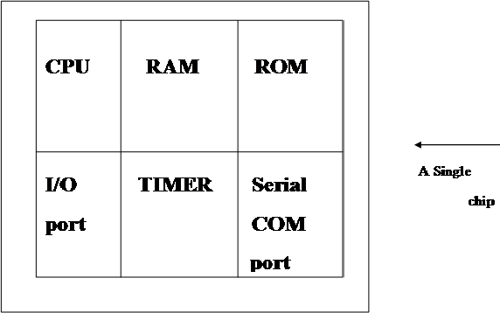

Fig 1.5 Microcontroller
-

COMPARISION BETWEEN MICROPROCESSOR AND MICROCONTROLLER
The microprocessor must have many additional parts to be operational as a computer whereas microcontroller requires no additional external digital parts.
- The prime use of microprocessor is to read data, perform extensive calculations on that data and store them in the mass storage device or display it. The prime functions of microcontroller are to read data, perform limited calculations on it, control its environment based on these data. Thus, the microprocessor is said to be general-purpose digital computers whereas the microcontroller is intended to be special purpose digital controller.
- Microprocessor need many opcodes for moving data from the external memory to the CPU, microcontroller may require just one or two, also microprocessor may have one or two types of bit handling instructions whereas microcontrollers have many.

PERIPHERALS:
Embedded Systems talk with the outside world via peripherals, such as
  - Serial Communication Interfaces (SCI): RS-232, RS-422, RS-485etc
  - Synchronous Serial Communication Interface: I2C, JTAG, SPI, SSC and ESSI
  - Universal Serial Bus (USB)
  - Networks: Ethernet, Controller Area Network, LAN networks, etc.

  - Timers: PLL(s), Capture/Compare and Time Processing Units

  - Discrete IO: aka General-Purpose Input/output (GPIO)

  - Ana log to Digital/Digital to Analog (ADC/DAC)

TOOLS:
As for other software, embedded system designers use compilers, assemblers, and debuggers to develop embedded system software. However, they may also use some more specific tools:

  - Utilities to add a checksum or CRC to a program, so the embedded system can check if the program is valid.

  - For systems using digital signal processing, developers may use a math workbench such as MATLAB, Simulink, Mathcad, or Mathematica to simulate the mathematics. They might also use libraries for both the host and target which eliminates developing DSP routines as done in DSP Nano RTOS and Unison Operating System.
  - Custom compilers and linkers may be used to improve optimization for the particular hardware.

  - An embedded system may have its own special language or design tool, or add enhancements to an existing language such as Forth or Basic.

  - Another alternative is to add a Real-time operating system or Embedded operating system, which may have DSP capabilities like DSP Nano RTOS.

CHAPTER 2

OVERVIEW OF THE PROJECT

2.1 INTRODUCTION

In parallel with the significant and exciting advancements in robot technologies, the use of humanoid robots to
support teaching strategies and learning goals has become a popular topic.
Different from the traditional instructional or learning tools, humanoid robots can exhibit mobile behaviours
and numerous repetitions and are very helpful to the students in developing problem-solving and
collaboration abilities.
Presently, the roles of humanoid robots in classrooms fall into four main categories: learning materials,
learning companions, teaching assistants and communication mediators to support group learning, respectively.
With the humanoid appearance, anthropomorphism, interaction, flexibility, repeatability and digital data representation, humanoid robots have great potential to be useful especially in preschool and primary school education. In this paper, limitations and challenges of the use of humanoid robots as teaching assistants are presented in addition to exploring the relationship between humanoid robots and performance in learning.
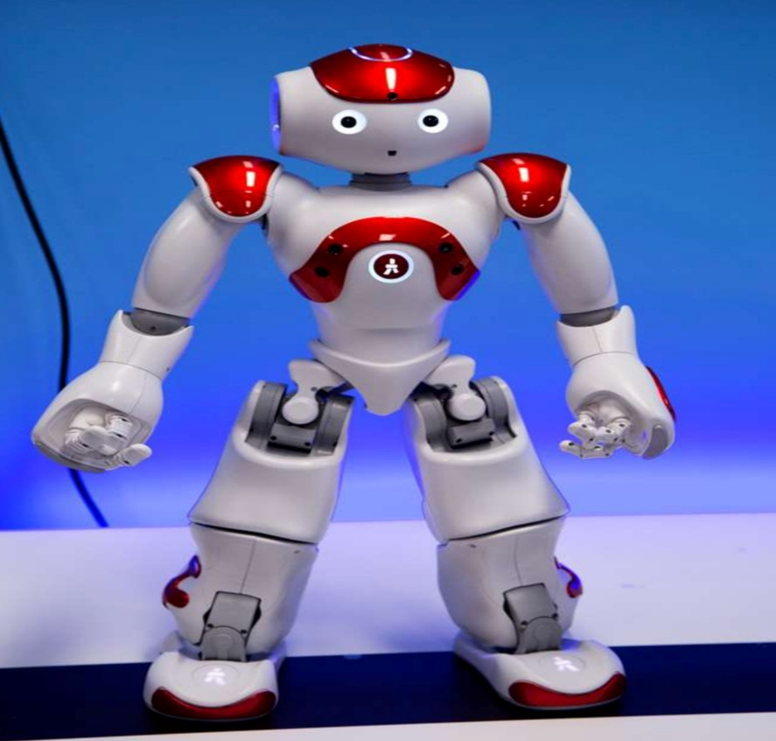

Fig 2.1 Human Guided Robot

2.2 LITERATURE SURVEY

Humanoid robotics is the field which is increasing in popularity day by day. Many groups are working on some issues like interacting, learning and controlling for applying them in human robotics. Currently, many types of robots are being used for learning goals and they range from simple robots to humanoid robots. The choice of the robot is generally dictated by the area of study and the age group of the student [1] (Sharkey, 2016). Compared to a human teacher, humanoid robots can help resolve issues related to shyness, frustration, reluctance and confidence better, and are being commonly used in many countries, especially for special education. In the twenty-first century, the educational landscape is rapidly evolving, driven by the integration of artificial intelligence (AI) and robotic technologies into traditional pedagogy. While educational robotics has long been a subject of research, the recent proliferation of social humanoid robots—machines characterized by a human-like form, gestures, and interactive capabilities—has opened new frontiers in early childhood and primary education. Unlike traditional, static educational tools, humanoid robots exist in the same physical space as students, creating a tangible and interactive learning environment that facilitates both cognitive and social-emotional development.
In education specifically, there are several areas where humanoid robots have been found to support learning and engagement. They have been shown to help develop computational thinking in young learners and foster greater engagement from pupils across a wide array of subjects in the curriculum. Humanoid robots are a wonderful educational aid in teaching children on the autistic spectrum. Having a human form has been proven to invoke a stronger connection and a sense of ownership in the students, and this has been especially effective using 'learning by teaching' and care-giving educational styles. The rapid advancement of technology enables the development of innovative approaches in education. In special education, technological tools used to address the individual needs of students have gained significant importance [2] (Bargagna, Stefania, et al). In this context, educational robots stand out as innovative tools that can be used to support students learning processes, enhance their social interactions, and develop their individual abilities. [3,4].
Educational robots are seen as potentially powerful tools to support students with special educational needs, such as autism spectrum disorder [5], intellectual disabilities und motor impairments [6] and learning disabilities [7]. These robots can help children improve their social skills, increase their attention spans, and engage with learning materials in a more interactive way. Another important aspect here is how the use of educational robots in special education, may evolve in the future. Current technological advancements are
making these robots smarter, more accessible, and more adaptable. However, critical questions still need to be
addressed, such as whether the infrastructure is sufficient for the widespread use of these technologies, how educators can access these technologies, and whether such technology use might risk exacerbating inequalities in education [8]. In 2021, Bartneck C proposed a report on an introduction to high- tech social agents, intelligent tutors, and curricular tools. Which gives to children to gain knowledge with robots [10]. In 2018 Ramchandran proposed a project on the robot for education [11].
In 2021, Woo H proposed a report on the use of social robots in classrooms which gives the students on clear clarification of doubts and guidance to children with how to behave in front of elders.[12]
In 2022, Velentza A proposed a report on the Human-robot interaction metholodgy which helps to children to interact with new persons easily.[13]
In 2023, Kim Y and Kanero J proposed a report on the child robot interaction it is same like the Velentza report and it can easily help to children with new existing world and behaviour with each other.[14][15]
2.3 EXISTING SYSTEM
The existing system of humanoid robots for children’s education using embedded systems and IoT is designed to provide interactive and engaging learning experiences through pre-programmed functionalities. These robots are built using embedded components such as microcontrollers, sensors, and actuators, which enable them to perform basic actions like movement, speech, and response to inputs. Sensors such as cameras and microphones help the robot perceive the environment, while actuators like motors and speakers allow it to interact physically and verbally with children. In many existing systems, IoT technology is integrated to connect the robot to the internet, allowing teachers or administrators to update educational content, monitor student interactions, and control the robot remotely. The robots are commonly used to teach basic subjects such as alphabets, numbers, storytelling, and simple problem-solving through voice interaction and predefined lessons. They can also conduct quizzes, recognize simple commands, and maintain student engagement through gestures and expressions. However, most existing systems are limited by their dependence on pre-programmed instructions, lack of advanced intelligence, high cost, and minimal emotional understanding. Despite these limitations, they play a significant role in enhancing classroom interaction, supporting special education, and making learning more attractive and effective for children.
DISADVANTAGES OF EXISTING SYSTEM
- Limited Individual Attention: In traditional education systems, teachers often handle a large number of students at once, making it difficult to provide equal attention to every child. Due to this limitation, some students may struggle to understand concepts properly. A humanoid robot integrated with embedded systems and IoT can overcome this issue by interacting with each student individually, ensuring better understanding and personalized engagement.
- No 24/7 Learning Support: Conventional learning methods are restricted to school hours, and students may not receive help outside class time. This limits continuous learning, especially when students want to study at their own pace. Humanoid robots with IoT connectivity can provide round-the-clock educational support, allowing children to learn anytime and anywhere.
- Delayed Doubt Clarification: In existing systems, students often need to wait until the next class or available time of the teacher to clarify their doubts. This delay can reduce learning efficiency and cause confusion. Humanoid robots can instantly respond to queries using embedded processing and cloud-based IoT resources, enabling immediate doubt clarification.
- No Personalized Learning: Traditional classrooms follow a common teaching approach for all students, regardless of their learning abilities. This results in some students falling behind while others may not feel challenged. Humanoid robots can analyze student performance and adapt teaching methods accordingly, offering personalized learning experiences tailored to each child.
- Difficulty in Monitoring Student Progress Continuously: Tracking the progress of each student manually is time-consuming and sometimes inaccurate. Teachers may not be able to monitor every student's improvement regularly. With IoT-enabled humanoid robots, data can be continuously collected, analyzed, and stored, providing real-time insights into student performance and progress.
- Less Motivation and Curiosity: Traditional teaching methods can sometimes be monotonous, leading to reduced interest among children. Lack of interactive and engaging content may decrease curiosity and motivation to learn. Humanoid robots, with their interactive behavior, gestures, and multimedia capabilities, can make learning more fun and engaging, thereby increasing student interest and curiosity.

PROPOSED SYSTEM

The main goal of this project is to design and develop an intelligent humanoid robot that assists children in learning by providing interactive, personalized, and continuous educational support using embedded systems and IoT technology.

Humanoid Robot as Learning Assistant – Acts as an interactive tutor to support children in daily learning.

Embedded Controller Unit – Uses microcontrollers (like Arduino/Raspberry Pi) to control robot movements, speech, and responses.

Interactive Voice Communication – Robot listens to children’s questions and responds

using speech recognition and text-to-speech.

Smart Learning Support – Helps in subjects like math, science, spelling, and general knowledge.

Homework & Reminder System – Reminds students about homework, tests, and study schedules.

Real-Time Doubt Clarification – Provides instant responses to student queries anytime

Remote Access – Parents and teachers can monitor and control the robot through mobile or web apps.

Safe & Child-Friendly Design – Designed with safety sensors and soft materials for children.

2.4.1 BLOCK DIAGRAM OF PROPOSED SYSTEM
ESP32-CAM
video Capture
Laptop Server
Voice processing & AI
Wi-Fi

D
ESP32 (Audio Module)
Text to speech
ESP32 (Mic Module)
Microphone

Speech to Text
ESP32 (Audio Module)

MAX98357A
I2C Amplifier
Text to speech

Battery Pack
ARDUINO
CONTROLLER
Ultrasonic
Sensor
L293D Motor
Driver

Ultrasonic
Sensor

SERVO
Motors
DC MOTORS

Fig 2.2 Block Diagram of proposed system

HARDWARE COMPONENTS

ESP32 modules

Arduino controller

I2C microphone

Laptop-based AI server

I2C amplifier and speaker

Control motors, servos

Ultrasonic sensors

ESP32 CAM

SOFTWARE COMPONENTS

Arduino IDE

Python

C++

TECHNOLOGY USED

- IOT

CHAPTER 3
IOT TECHNOLOGY

INTRODUCTION OF IOT TECHNOLOGY
- The term "Internet of Things" has come to describe a number of technologies and research disciplines that enable the Internet to reach out into the real world of physical objects.
- The Internet of Things, also called The Internet of Objects, refers to a wireless network between objects.
- From any time, any place connectivity for anyone, we will now have connectivity for anything!

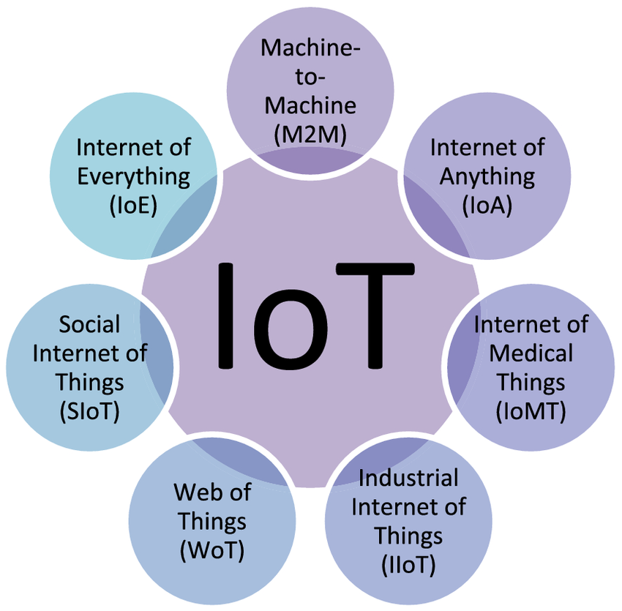

Fig 3.1 IOT Technology

3.1.1 THE VISION
The IoT is a network of internet connected physical objects- embedded devices, vehicles, sensors, computers; and these objects exchange data among themselves and other systems. Another definition of IoT is “The Internet of Things allows people and things to be connected Anytime, Anyplace, with Anything and Anyone, ideally using Any path/network and Any service”. In fact, IoT stands for “a world-wide network of interconnected objects uniquely addressable, based on standard communication protocols”. The number of such addressable objects is growing rapidly. The IoT paradigm is also defined as an intersection of three vision areas: Internet oriented vision, things-oriented vision, and semantic oriented vision. Figure 3.2, which is adapted from, shows these vision areas and their intersections. Sensors, actuators, sensor networks, RFID, near
field communications (NFC), electronic product code (EPC) technologies, wireless sensor, and actuator networks (WSAN) are classified as part of the things-oriented vision. Semantic technologies (web, languages, execution environment, and so on), reasoning over data, are classified as a semantic oriented vision. Finally, Internet technologies and the WoT are located in Internet oriented vision. There are also some technologies in the overlapped regions of these visions. For example, semantic sensor networks are in the intersection area of the things and semantic oriented visions. The intersection of all three vision areas is the IoT.

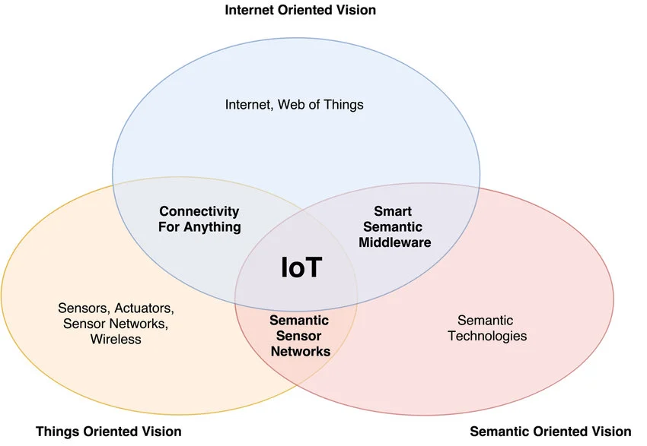

Fig 3.1.1 VISION OF IOT

Three main visions of the Internet of Things (IoT). These three perspectives—Internet Vision, Things Vision, and Semantic Oriented Vision—describe different ways researchers and engineers approach the development of IoT systems.
The core concept is that the full potential of IoT is reached at the intersection of these three paradigms.
1. Internet Vision (Network-Oriented)
This perspective focuses on the networking aspect of IoT. It treats "things" as nodes in a global network, primarily using Internet Protocols (like IPv4 or IPv6) to enable communication between physical devices. The goal here is to make every object uniquely addressable and reachable via the web.
2. Things Vision (Object-Oriented)
This vision centres on the physical objects themselves and the technologies that make them "smart". Key components include:
- Identification: Technologies like RFID (Radio Frequency Identification) and EPC (Electronic Product Code).
- Sensing: Sensors that allow objects to harvest information from their environment.
- Actuation: Devices that allow objects to interact with or control the physical world.
3. Semantic Oriented Vision (Knowledge-Oriented)
As the number of connected devices grows, the amount of raw data becomes overwhelming. This vision focuses on:
- Meaning: Using "Semantic Web" technologies (like ontologies and RDF) to give meaning to the data so machines can understand it without human intervention.
- Reasoning: Processing raw data into consistent, useful information for better representation and decision-making.
- Interoperability: Ensuring different systems can understand and use each other's data.
A vivid description of the vision of Internet-of-Things (Authorized by Jon Berkeley) The impact caused by the IoT to human life will be as huge as the internet has caused in the past decades, so the IoT is recognized as “the next of internet”. A part of the enabling technologies are sensors and actuators, Wireless Sensor Network (WSN), Intelligent and Interactive Packaging (I2Pack), real-time embedded system, Microelectromechanical Systems (MEMS), mobile internet access, cloud computing, Radio Frequency Identification (RFID), Machine-to-Machine (M2M) communication, human machine interaction (HMI), middleware, Service Oriented Architecture (SOA), Enterprise Information System (EIS), data mining, etc. With various descriptions from various viewpoints, the IoT has become the new paradigm of the evolution of information and communication technology (ICT).

CHARACTERISTICS FOR INTERNET OF THINGS:
    - Connectivity

    - Intelligence and Identity

    - Scalability

    - Dynamic and Self-Adapting(complexity)

    - Safety

Internet of Things (IoT) devices and systems to understand and respond to the environment and context in which they are operating. This is achieved through the use of sensors and other technologies that can detect and collect data about the environment.
Context awareness is a critical aspect of IoT, as it enables IoT devices and systems to make decisions and take actions based on the context in which they are operating.
For example, in a smart home, a context-aware IoT system could adjust the temperature, lighting, and other systems based on the time of day, the presence of people in the home, and other factors.
In addition, context awareness is also used to improve the efficiency and effectiveness of IoT systems by reducing the amount of data that needs to be transmitted and processed. For example, a context-aware IoT system might only collect and transmit data when it is relevant to the current context, such as when a person is in the room or when the temperature changes significantly.
Overall, context awareness is a key aspect of IoT and is essential for realizing the full potential of IoT and creating truly intelligent and responsive systems. IoT devices are designed to be context-aware, taking into account the environment and context in which they are operating in order to provide more relevant and useful information and services.
Overall, these characteristics of the IoT allow it to create new and innovative services and applications that can transform the way we live and work.
Connectivity is an important requirement of the IoT infrastructure. Things of IoT should be connected to the IoT infrastructure. Anyone, anywhere, anytime can connect, this should be guaranteed at all times. For example, the connection between people through Internet devices like mobile phones, and other gadgets, also a connection between Internet devices such as routers, gateways, sensors, etc.
The extraction of knowledge from the generated data is very important. For example, a sensor generates data, but that data will only be useful if it is interpreted properly. Each IoT device has a unique identity. This identification is helpful in tracking the equipment and at times for querying its status.
The number of elements connected to the IoT zone is increasing day by day. Hence, an IoT setup should be capable of handling the massive expansion. The data generated as an outcome is enormous, and it should be handled appropriately.
IoT devices should dynamically adapt themselves to changing contexts and scenarios. Assume a camera meant for surveillance. It should be adaptable to work in different conditions and different light situations (morning, afternoon, and night).
There is a danger of the sensitive personal details of the users getting compromised when all his/her devices are connected to the internet. This can cause a loss to the user. Hence, data security is the major challenge. Besides, the equipment involved is huge. IoT networks may also be at risk. Therefore, equipment safety is also critical.
Following on from the Internet of computers, when our servers and personal computers were connected to a global network, and the Internet of mobile telephones, when it was the turn of telephones and other mobile units, the next phase of development is the Internet of things, when more or less anything will be connected and managed in the virtual world. This revolution will be the Net’s largest enlargement ever and will have sweeping effects on every industry — and all of our everyday lives.
Smart connectivity with existing networks and context-aware computation using network resources is an indispensable part of IoT. With the growing presence of Wi-Fi and 4G-LTE wireless Internet access, the evolution towards ubiquitous information and communication networks is already evident. However, for the Internet of Things vision to successfully emerge, the computing paradigm will need to go beyond traditional mobile computing scenarios that use smart phones and portables, and evolve into connecting everyday existing objects and embedding intelligence into our environment. For technology to disappear from the consciousness of the user, the Internet of Things demands: a shared understanding of the situation of its users and their appliances, software architectures and pervasive communication networks to process and convey the contextual information to where it is relevant, and the analytics tools in the Internet of

Things that aim for autonomous and smart behavior. With these three fundamental grounds in place, smart connectivity and context-aware computation can be accomplished.

DEFITNITION OF INTERNET OF THINGS (IOT)
“Today computers—and, therefore, the Internet—are almost wholly dependent on human beings for information. Nearly all of the roughly 50 petabytes (a petabyte is 1,024 terabytes) of data available on the Internet were first captured and created by human beings— by typing, pressing a record button, taking a digital picture, or scanning a bar code. Conventional diagrams of the Internet … leave out the most numerous and important routers of all - people. The problem is, people have limited time, attention and accuracy—all of which means they are not very good at capturing data about things in the real world. And that's a big deal. We're physical, and so is our environment … You can't eat bits, burn them to stay warm or put them in your gas tank. Ideas and information are important, but things matter much more. Yet today's information technology is so dependent on data originated by people that our computers know more about ideas than things. If we had computers that knew everything there was to know about things— using data they gathered without any help from us—we would be able to track and count everything, and greatly reduce waste, loss and cost. We would know when things needed replacing, repairing or recalling, and whether they were fresh or past their best. The Internet of Things has the potential to change the world, just as the Internet did. Maybe even more so”.
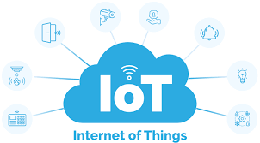

Fig 3.3 INTERNET OF THINGS (IOT)

“Things are active participants in business, information and social processes where they are enabled to interact and communicate among themselves and with the environment by exchanging data and information sensed about the environment, while reacting autonomously to the real/physical world events and influencing it by running processes that trigger actions and create services with or without direct human intervention.”
“The Internet of Things represents an evolution in which objects are capable of interacting with other objects. Hospitals can monitor and regulate pacemakers’ long distance, factories can automatically address production line issues and hotels can adjust temperature and lighting according to a guest's preferences, to name just a few examples.”

24 HOURS IN FUTURE WITH INTERNET OF THINGS

From morning to night, IoT works quietly in the background, connecting devices and making everyday
life smoother through continuous data exchange and automation. In the morning, smart alarms wake a
person based on sleep patterns, while connected appliances like coffee makers and lighting systems adjust
automatically to personal preferences. Wearable devices begin tracking health metrics such as heart rate
and activity, sending real-time data to mobile apps for monitoring and insights.

As the day progresses, IoT plays a major role in transportation and work environments. Smart traffic
systems monitor congestion and adjust signals to reduce delays, while connected vehicles provide
navigation updates and safety alerts. In workplaces and industries, machines communicate with each
other to optimize production, detect faults, and maintain efficiency without interruptions.

Environmental sensors regulate temperature, lighting and air quality to create comfortable and energy-
efficient spaces
During the afternoon and evening, IoT continues to support daily routines by enabling remote control
of home devices. Users can monitor security cameras, lock doors, or adjust appliances from their smart
phones even when they are away. In healthcare, IoT devices track patient conditions continuously and
can alert doctors or caregivers if any abnormal readings are detected.

At night, IoT systems enhance safety and comfort by managing lighting, activating security
systems, and optimizing energy usage. Smart homes can automatically switch off unused devices, adjust
temperatures for better sleep, and ensure all systems are secure. Throughout the entire day, IoT operates
as an always-on network, collecting data, analyzing patterns, and making intelligent decisions to improve
convenience, efficiency, and quality of life without requiring constant human involvement.

The future of 24-hour operation in IoT is centred on systems that never stop sensing, thinking, and
acting. Devices are no longer limited to collecting data at intervals; instead, they generate continuous
streams of information that are analysed instantly to produce immediate responses. This constant flow
enables environments that are aware of changes the moment they occur and can react without waiting
for human input.

ARCHITECTURE OF INTERNET OF THINGS
Architecture of internet Of Things contains basically 4 layers:
- Application Layer

- Gateway and the network layer

- Management Service layer

- Sensor layer

Data Flow 4 Stage IoT Architecture
Application Layer

Smart Application

Data Processing Layer

Process Information

Network Layer
Data Transmission

Sensing Layer

Data Gathering

Fig 3.4 ARCHITECTURE OF IOT

APPLICATION LAYER:
      - Lowest Abstraction Layer
      - With sensors we are creating digital nervous system.

      - Incorporated to measure physical quantities

      - Interconnects the physical and digital world

      - Collects and process the real time information

GATEWAY AND THE NETWORK LAYER:

      - Robust and High-performance network infrastructure

      - Supports the communication requirements for latency, bandwidth or security

      - Allows multiple organizations to share and use the same network independently

MANAGEMENT LAYER:
      - Capturing of periodic sensory data

      - Data Analytics (Extracts relevant information from massive amount of raw data)

      - Streaming Analytics (Process real time data)

      - Ensures security and privacy of data.

SENSOR LAYER:
- Provides a user interface for using IoT.
- Different applications for various sectors like Transportation, Healthcare, Agriculture, Supply chains, Government, Retail etc.

3.6 INTERNET OF THINGS ELEMENTS
There are three IoT components which enables seamless:
- Hardware—made up of sensors, actuators and embedded communication hardware
- Middleware—on demand storage and computing tools for data analytics and
- Presentation—novel easy to understand visualization and interpretation tools which can be widely accessed on different platforms and which can be designed for different applications

3.7 RADIO FREQUENCY IDENTIFICATION (RFID)
RFID technology is a major breakthrough in the embedded communication paradigm which enables design of microchips for wireless data communication. They help in the automatic identification of anything they are attached to acting as an electronic barcode. The passive RFID tags are not battery powered and they use the power of the reader’s interrogation signal to communicate the ID to the RFID reader. This has resulted in many applications particularly in retail and supply chain management. The applications can be found in transportation (replacement of tickets, registration stickers) and access control
applications as well. The passive tags are currently being used in many bank cards and road toll tags which
are among the first global deployments. Active RFID readers have their own battery supply and can
instantiate the communication. Of the several applications, the main application of active RFID tags is in
port containers for monitoring cargo.

3.8 WIRELESS SENSOR NETWORKS (WSN)
Recent technological advances in low power integrated circuits and wireless communications have made available efficient, low cost, low power miniature devices for use in remote sensing applications. The combination of these factors has improved the viability of utilizing a sensor network consisting of a large number of intelligent sensors, enabling the collection, processing, analysis and dissemination of valuable information, gathered in a variety of environments. Active RFID is nearly the same as the lower end WSN nodes with limited processing capability and storage. The scientific challenges that must be overcome in order to realize the enormous potential of WSNs are substantial and multidisciplinary in nature. Sensor data are shared among sensor nodes and sent to a distributed or centralized system for analytics. The components that make up the WSN monitoring network include:
- WSN hardware—Typically a node (WSN core hardware) contains sensor interfaces, processing units, transceiver units and power supply. Almost always, they comprise of multiple A/D converters for sensor interfacing and more modern sensor nodes have the ability to communicate using one frequency band making them more versatile.
- WSN communication stack—The nodes are expected to be deployed in an ad-hoc manner for most applications. Designing an appropriate topology, routing and MAC layer is critical for the scalability and longevity of the deployed network. Nodes in a WSN need to communicate among themselves to transmit data in single or multi-hop to a base station. Node drop outs, and consequent degraded network lifetimes, are frequent.
WSN Middleware—A mechanism to combine cyber infrastructure with a Service Oriented Architecture (SOA) and sensor networks to provide access to heterogeneous sensor resources in a
deployment independent manner. This is based on the idea of isolating resources that can be used by several applications. A platform-independent middleware for developing sensor applications is required, such as an Open Sensor Web Architecture.
- Secure Data aggregation—An efficient and secure data aggregation method is required for extending the lifetime of the network as well as ensuring reliable data collected from sensors. Node failures are a common characteristic of WSNs, the network topology should have the capability to heal itself. Ensuring security is critical as the system is automatically linked to actuators and protecting the systems from intruders becomes very important.

3.9 APPLICATIONS:
There are several application domains which will be impacted by the emerging Internet of Things. The applications can be classified based on the type of network availability, coverage, scale, heterogeneity, repeatability, user involvement and impact.
We categorize the applications into four application domains:
- Smart Agriculture
- Smart Vehicle
- Smart Home
- Smart Healthcare

There is a huge crossover in applications and the use of data between domains. For instance, the Personal and Home IoT produces electricity usage data in the house and makes it available to the electricity (utility) company which can in turn optimize the supply and demand in the Utility IoT. The internet enables sharing of data between different service providers in a seamless manner creating multiple business opportunities.

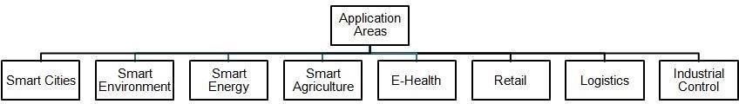

Fig 3.5 Applications of IOT

3.9.1 SMART AGRICULTURE

Food is an integral part of life without which we cannot survive. However, it is an unfortunate fact that
A lot of food is wasted in developed countries like America while people starve in poorer countries
like Chad, Sudan, etc.

One way to feed everyone is through better agricultural practices which can be enhanced using
IoT applications. This can be done by first collecting data for a farm such as soil quality, sunlight levels,
seed type, and rainfall density from various sources like farm sensors, satellites, local weather stations,
etc. and then using this data with Machine Learning and IoT to create custom recommendations for each
farm that will optimize the planting procedure, irrigation levels required, fertilizer amount, etc.
Smart farming, also known as smart agriculture, is the adoption of advanced technologies and
Data-driven farm operations to optimize and improve sustainability in agricultural production.
Technologies used for smart farming include artificial intelligence (AI), automation and the
InternetofThings (IoT).
Chief among them is food security: food production must increase by 70% by 2050 to keep pace with
global population growth, according to the International Monetary Fund.
Climate change is making it harder to secure enough food. It reduces crop yields and endangers
the availability of natural resources such as water for irrigation.
In addition to climate issues, the agricultural sector also faces profitability challenges amid the rising
costs of inputs like fertilizer, volatile commodity prices and increasing regulatory requirements.
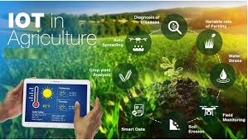

Fig 3.6 IOT in Agriculture

3.9.2 SMART VEHICLE

A smart vehicle is a modern automobile equipped with advanced electronics, sensors, internet connectivity,
and artificial intelligence (AI) that enable it to interact with its surroundings, optimize performance, and
improve safety. These vehicles are designed to enhance the driving experience, increase efficiency, and reduce
traffic congestion.
Innovative features and underpinning technologies. Autonomous driving – The zenith of smart vehicle innovation is autonomous driving, which harnesses artificial intelligence (AI), machine learning, and a suite of sensors including LiDAR, radar, and cameras.
Smart vehicles use a bunch of fancy technologies like the Internet of things (IoT), Artificial Intelligence (AI), and high-tech sensors to make driving way better. Smart vehicle utilizes technology to enhance safety, efficiency, connectivity, and an overall driving experience.
Benefits of Smart Agriculture:
- Enhanced Safety Features
- Improved Connectivity
- Autonomous Driving Capabilities
- Eco-Friendly Innovations+
- Personalized Driving Experience
- Future Prospects
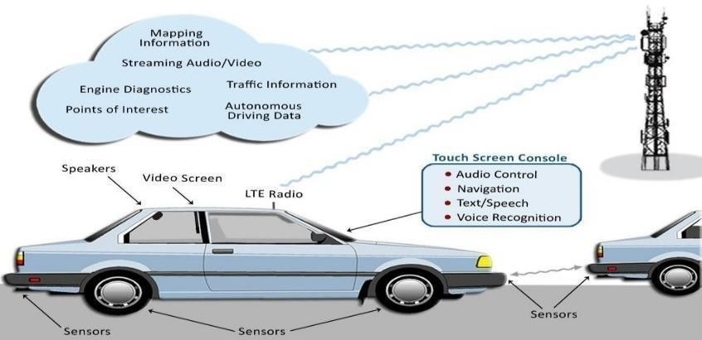
Fig 3.7 IOT in VEHICLE

3.9.3 SMART HOME

A smart home is equipped with internet-connected devices that allow the home's security features, appliances, climate controls, and more to be operated remotely via a mobile device. They can be set up using either hardwired or wireless systems.
Outdoor security cameras, video doorbells, smart locks, smart entertainment speakers, connected thermostats, pet cameras, and smart thermostats are among the many internet-connected home products now readily available to consumers.
A smart home’s devices are connected with each other and can be accessed through one central point—a mobile phone, tablet, laptop, or game console. Door locks, televisions, thermostats, home monitors, cameras, lights, and appliances such as refrigerators can be controlled through one home automation system. The remote-control system allows users to schedule tasks, trigger devices, or monitor results from anywhere.
Smart home appliances have self-learning skills. They can learn the homeowner’s schedules and make adjustments as needed. Users benefit from energy savings by using features that control home lighting and temperature remotely.
Some home automation systems alert the homeowner if any motion is detected in the home when they're away. Others can call the police or fire department if dangerous situations are detected.
Once connected, services such as a smart doorbell, smart security system, and smart appliances become part of the internet of things (IoT) technology, a network of physical objects capable of gathering and sharing electronic information.

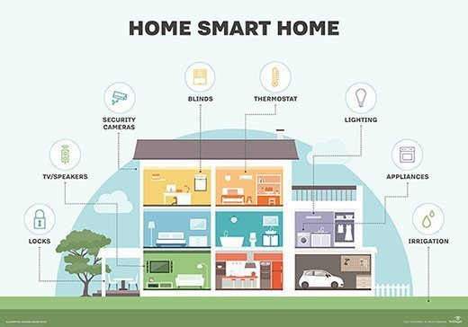

Fig 3.8 IOT in HOME

3.9.4 HEALTHCARE

Smart healthcare in IoT involves using connected devices—wearables, sensors, and

medical equipment—to monitor patient health data in real time, enhancing care quality while reducing
costs. These systems, which include remote patient monitoring and smart diagnostics, enable proactive treatment, early disease detection, and improved medication adherence.

Smart Healthcare is a health service system that uses technology, such as wearable devices, asset trackers, and environmental monitors, to dynamically access information and connect people, materials, and institutions related to healthcare.

IoT applications in healthcare (Internet of Medical Things, or IoMT) enhance patient care by enabling real-time, remote monitoring, increasing diagnostic accuracy, and optimizing hospital operations. Key uses include wearables tracking vitals (heart rate, glucose), smart pills, automated drug delivery, and AI-driven predictive maintenance for medical equipment, creating a faster, more personalized, and efficient system.
- Sensors & Smart Devices. Sensor technologies, such as wearable sensors and devices, provide many benefits for health management
- Biosensors.
- Patient Health Portals.
- Machine Learning Applications
- Blockchain-based Initiatives

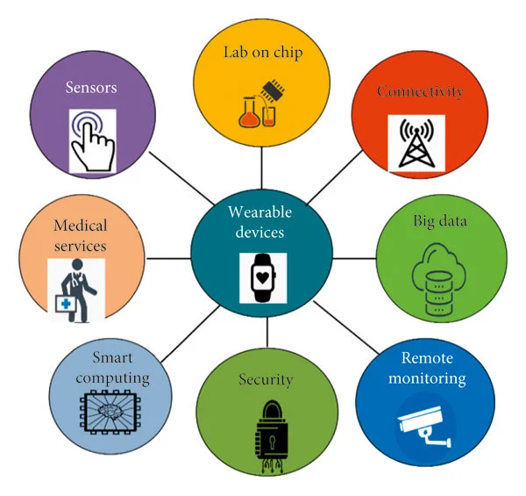

Fig 3.9 IOT in HEALTHCARE

3.10 CLOUD CENTRIC INTERNET OF THINGS
The vision of IoT can be seen from two perspectives— ‘Internet’ centric and ‘Thing’ centric. The Internet centric architecture will involve internet services being the main focus while data is contributed by the objects. In the object centric architecture, the smart objects take the center stage.
In order to realize the full potential of cloud computing as well as ubiquitous sensing, a combined framework with a cloud at the center seems to be most viable. This not only gives the flexibility of dividing associated costs in the most logical manner but is also highly scalable. Sensing service providers can join the network and offer their data using a storage cloud; analytic tool developers can provide their software tools; artificial intelligence experts can provide their data mining and machine learning tools useful in converting information to knowledge and finally computer graphics designers can offer a variety of visualization tools. Cloud computing can offer these services as Infrastructures, Platforms or Software where the full potential of human creativity can be tapped using them as services.
The new IoT application specific framework should be able to provide support for:

      - Reading data streams either from sensors directly or fetch the data from databases
      - Easy expression of data analysis logic as functions/operators that process data streams in a transparent and scalable manner on Cloud infrastructures
      - If any events of interest are detected, outcomes should be passed to output streams, which are
connected to a visualization program. Using such a framework, the developer of IoT applications will able to harness the power of Cloud computing without knowing low-level details of creating reliable and scale applications.

3.11 BENEFITS OF INTERNET OF THINGS

- Improved citizen's quality of life

1. Healthcare from anywhere
2.Better safety, security and productivity

      - New business opportunities

1.IoT can be used in every vertical for improving the efficiency
2.Creates new businesses, and new and better jobs

      - Economic growth

1.Billions of dollars in savings and new services

      - Better environment

  - Saves natural resources and trees
  - Helps in creating a smart, greener and sustainable planet

      - Improved competitiveness

- Competitive in providing cutting edge products/services

3.12 OPEN CHALLENGES AND FUTURE DIRECTIONS
The proposed Cloud centric vision comprises a flexible and open architecture that is user centric and enables different players to interact in the IoT framework. It allows interaction in a manner suitable for their own requirements, rather than the IoT being thrust upon them. In this way, the framework includes provisions to meet different requirements for data ownership, security, privacy, and sharing of information.
Some open challenges are discussed based on the IoT elements presented earlier. The challenges include IoT specific challenges such as privacy, participatory sensing, data analytics, GIS based visualization and Cloud computing apart from the standard WSN challenges including architecture, energy efficiency, security, protocols, and Quality of Service.

3.13 ARCHITECTURE
Overall architecture followed at the initial stages of IoT research will have a severe bearing on the field itself and needs to be investigated. Most of the works relating to IoT architecture have been from the wireless sensor networks perspective.
European Union projects of SENSEI and Internet of Things- Architecture (IoT-A) have been addressing the challenges particularly from the WSN perspective and have been very successful in defining the architecture for different applications.

3.14 ENERGY EFFICIENT SENSING
Efficient heterogeneous sensing of the urban environment needs to simultaneously meet competing demands of multiple sensing modalities. This has implications on network traffic, data storage, and energy utilization. Importantly, this encompasses both fixed and mobile sensing infrastructure as well as continuous and random sampling. A generalized framework is required for data collection and modeling that effectively exploits spatial and temporal characteristics of the data, both in the sensing domain as well as the associated transform domains.

3.15 SECURE REPROGRAMMABLE NETWORKS AND PRIVACY
Security will be a major concern wherever networks are deployed at large scale. There can be many ways the system could be attacked—disabling the network availability; pushing erroneous data into the network; accessing personal information; etc.
The three physical components of IoT—RFID, WSN and cloud are vulnerable to such attacks.
Security is critical to any network and the first line of defense against data corruption is cryptography.

Of the three, RFID (particularly passive) seems to be the most vulnerable as it allows person tracking as well as the objects and no high-level intelligence can be enabled on these devices. These complex problems however have solutions that can be provided using cryptographic methods and deserve more research before they are widely accepted.
Against outsider attackers, encryption ensures data confidentiality, whereas message authentication codes ensure data integrity and authenticity. Encryption, however, does not protect against insider malicious attacks, to address which non cryptographic means are needed, particularly in WSNs. Also, periodically, new sensor applications need to be installed, or existing ones need to be updated. This is done by remote wireless reprogramming of all nodes in the network. Traditional network reprogramming consists solely of a data dissemination protocol that distributes code to all the nodes in the network without authentication, which is a security threat. A secure reprogramming protocol allows the nodes to authenticate every code update and prevent malicious installation. Most such protocols are based on the benchmark protocol Deluge. We need cryptographic add-ons to Deluge, which lays the foundation for
more sophisticated algorithms to be developed. Security in the cloud is another important area of research which will need more attention. Along with the presence of the data and tools, cloud also handles economics of IoT which will make it a bigger threat from attackers. Security and identity protection becomes critical in hybrid clouds where private as well as public clouds will be used by businesses. Remembering forever in the context of IoT raises many privacy issues as the data collected can be used in positive (for advertisement services) and negative ways (for defamation). Digital forgetting could emerge as one of the key areas of research to address the concerns and the development of an appropriate framework to protect personal data.

3.16 QUALITY OF SERVICE
Heterogeneous networks are (by default) multi-service; providing more than one distinct application or service. This implies not only multiple traffic types within the network, but also the ability of a single network to support all applications without QoS compromise. There are two application classes: throughput and delay tolerant elastic traffic of (e.g., monitoring weather parameters at low sampling rates), and the bandwidth and delay sensitive inelastic (real-time) traffic (e.g., noise or traffic monitoring), which can be further discriminated by data-related applications (e.g., high-vs.-low resolution videos) with different QoS requirements. Therefore, a controlled, optimal approach to serve different network traffics, each with its own application QoS needs is required. It is not easy to provide QoS guarantees in wireless networks, as segments often constitute ‘gaps’ in resource guarantee due to resource allocation and management ability constraints in shared wireless media. Quality of Service in Cloud computing is another major research area which will require more and more attention as the data and tools become available on clouds. Dynamic scheduling and resource allocation algorithms based on particle swarm optimization are being developed. For high-capacity applications and as IoT grows, this could become a bottleneck.

3.17 CLOUD COMPUTING
Integrated IoT and Cloud computing applications enabling the creation of smart environments such as Smart Cities need to be able to:
- Combine services offered by multiple stakeholders
- Scale to support a large number of users in a reliable and decentralized manner.

They need to be able operate in both wired and wireless network environments and deal with

constraints such as access devices or data sources with limited power and unreliable connectivity.
The Cloud application platforms need to be enhanced to support:
  - The rapid creation of applications by providing domain specific programming tools and environments.
  - Seamless execution of applications harnessing capabilities of multiple dynamic and heterogeneous resources to meet quality of service requirements of diverse users.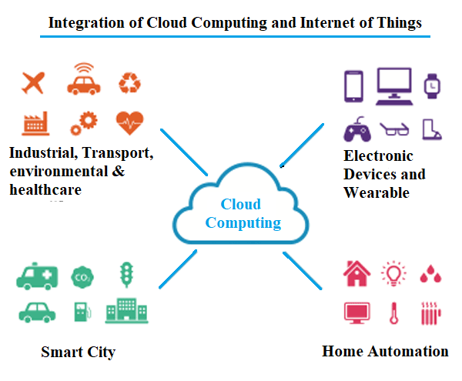

Fig 3.17 Cloud Computing in IOT

Parameter | Traditional Teaching Method | Educational Software | Humanoid Robot Using Embedded and Iot
Teaching style | Teacher explains using board, books, and notes | Interactive lessons through multimedia and animations | Robot explains lessons using voice, gestures, and movements
Student Engagement | Moderate engagement depending on teacher interaction and communication | High engagement using videos, quizzes, and games | Very high engagement through robot interaction and communication
Personalization | Limited personalization for students | Some adaptive learning algorithms | High personalization using sensors and IoT data analysis
Interaction Level | Mostly one-way communication | Two-way interaction  via touch or keyboard | Multi-modal interaction (voice, gestures, sensors)
Practical Demonstration | Limited demonstration due to time/resources | Virtual simulations  on screen | Real-time demonstrations using robot movements and actions
Accessibility | Only available in classroom | Available on mobile  phones or computers | Accessible through robot and IoT remote monitoring
Learning Motivation | Moderate | High for short duration | Very high due to humanoid interaction
Monitoring & Feedback | Teacher manually checks  progress | Automatic quiz feedback and progress reports | Real-time monitoring using IoT dashboards and analytics
Technology Integration | Low technology integration | Medium technology usage | High technology (Embedded systems, sensors, IOT connectivity)
Future Scalability | Limited improvement | Scalable with software updates | Highly scalable with IoT updates and AI integration
Table 3.17: Confirmation Table on Proposed System of Humanoid Robot for Children Education

CHAPTER-4

HARDWARE REQUIREMENT

HARDWARE COMPONENTS ARE

    - Power Supply
    - Arduino UNO

    - Battery

    - ESP32 Modules
    - I2C Microphone

    - Laptop-Based AI Server

    - I2C Amplifier and Speaker
    - DC Motor

    - Ultrasonic Sensors

    - ESP32 CAM

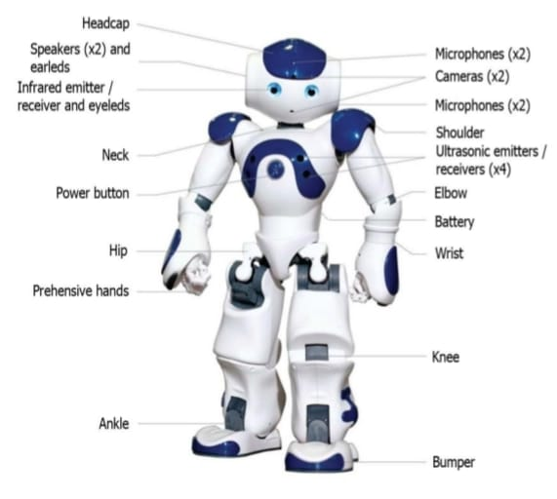

Fig 4 Human Guided Robot

ARDUINO UNO INTRODUCTION
The Arduino is a family of microcontroller boards to simplify electronic design, prototyping and experimenting for artists, hackers, hobbyists, but also many professionals. People use it as brains for their robots, to build new digital music instruments, or to build a system that lets your house plants tweet you when they’re dry. Arduino’s (we use the standard Arduino Uno) are built around an AT mega microcontroller — essentially a complete computer with CPU, RAM, Flash memory, and input/output pins, all on a single chip. Unlike, say, a Raspberry Pi, it’s designed to attach all kinds of sensors, LEDs, small motors and speakers, servos, etc. directly to these pins, which can read in or output digital or analog voltages between 0 and 5 volts. The Arduino connects to your computer via USB, where you program it in a simple language (C/C++, similar to Java) from inside the free Arduino IDE by uploading your compiled code to the board. Once programmed, the Arduino can run with the USB link back to your computer, or stand-alone without it — no keyboard or screen needed, just power.
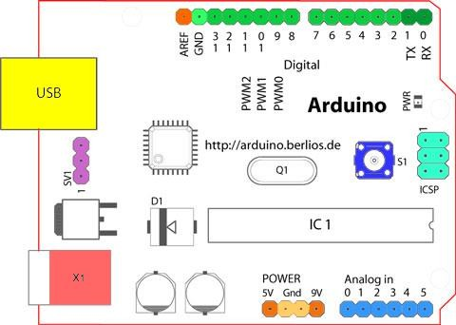
Fig 4.1 Structure of Arduino Board

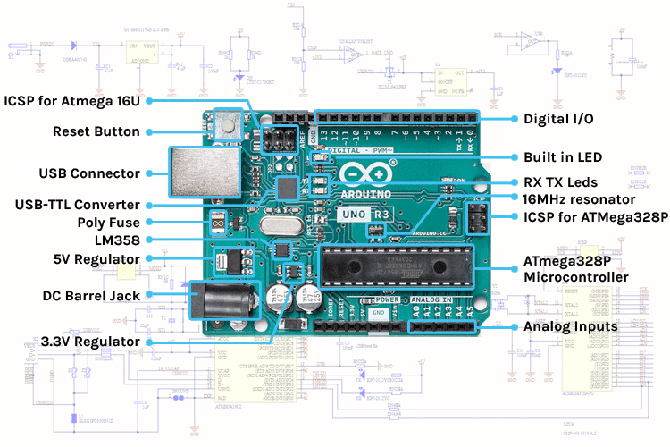

Fig 4.1.1(a) Arduino Board

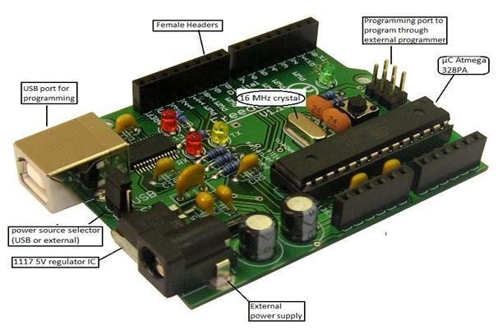

Fig 4.1.1 (b)Arduino Board
Starting clockwise from the top center:
    - Analog Reference pin (orange)
    - Digital Ground (light green)
    - Digital Pins 2-13 (green)
    - Digital Pins 0-1/Serial In/Out - TX/RX (dark green) - These pins cannot be used for digital i/o (Digital Read and Digital Write) if you are also using serial communication (e.g.Serial begin).
    - Reset Button - S1 (dark blue)
    - In-circuit Serial Programmer (blue-green)
    - Analog In Pins 0-5 (light blue)
    - Power and Ground Pins (power: orange, grounds: light orange)
    - External Power Supply In (9-12VDC) - X1 (pink)
    - Toggles External Power and USB Power (place jumper on two pins closest to desired supply) - SV1 (purple)
    - USB (used for uploading sketches to the board and for serial communication between the board and the computer; can be used to power the board) (yellow)
4.2 ESP32 MODULE
ESP32 is a single chip 2.4 GHz Wi-Fi and Bluetooth combo chip designed with TSMC ultra-low power 40 nm technology. It is designed and optimized for the best power performance, RF performance, robustness, versatility, features, and reliability, for a wide variety of applications, and different power profiles.
The ESP32 is the most integrated solution for Wi-Fi + Bluetooth applications in the industry with less than 10 external components. ESP32 integrates the antenna switch, RF balun, power amplifier, low noise receives amplifier, filters, and power management modules. As such, the entire solution occupies minimal Printed Circuit Board (PCB) area.
ESP32 is designed for mobile, wearable electronics, and Internet of Things (IoT) applications. It has many features of the state-of-the-art low power chips, including fine resolution clock gating, power modes, and dynamic power scaling.

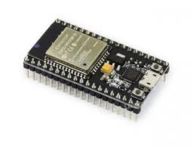
Fig 4.2 ESP32 Module

The ESP32 development board promises to revolutionize the Internet of Things (IoT), creating a powerful
and reliable platform for low-cost, highly integrated applications. Featuring an open-source operating system,
built-in Wi-Fi, and Bluetooth support, along with two high-speed processors - one dedicated to
communication tasks such as packet processing while another handles application code execution.
It also supports various industry standard formats including the JTAG debug interface so you can optimize
your coding designs without worrying about compatibility issues. Additionally, it comes preloaded with
advanced features like PWM outputs & multiple ADCs which makes this perfect for any IoT project that
looks at making life easier by automating device operations through remote control services from anywhere
in the world within seconds.

4.3 I2C MICROPHONE

- The I2C microphone is used to capture audio signals from the surrounding environment.
- It converts sound waves into digital signals and sends them to the controller through the I2C protocol.
- This microphone is mainly used for voice input and speech recognition applications. It provides
accurate and noise-reduced audio input for AI processing.

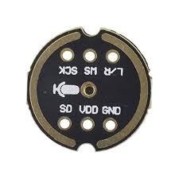
Fig 4.3 I2C MICROPHONE

An I2C microphone is a digital microphone module that communicates with microcontrollers using the I2C
(Inter-Integrated Circuit) protocol. It is commonly used in embedded systems, IoT devices, and robotics for
capturing sound data in a simple and efficient way.
An I2C microphone integrates a microphone sensor and a digital interface that sends audio data through the
I2C bus. Unlike analog microphones, it does not require external analog-to-digital conversion because the signal
is processed internally.
An I2C microphone is a convenient and efficient choice for low-to-medium audio applications in embedded systems. While it may not provide high-fidelity audio, its simplicity and ease of integration make it ideal for educational projects and IoT-based humanoid robots.

SPECIFICATIONS:

Communication interface- Supports multiple devices via unique I2C addresses

Operating Voltage- Typically 1.8V to 3.3V (some modules support 5V with regulator)

Audio Resolution- Usually 12-bit to 24-bit ADC resolution, Determines accuracy of sound signal conversion.

Sampling Rate- Typical range: 8 kHz to 48 kHz, Higher sampling rate → better sound quality.

Frequency Range- Common range: 20 Hz to 20 kHz (human hearing range),Some low-cost

modules may have narrower range

4.4 Laptop Based Server

- The laptop-based AI server acts as the brain of the system.
- It runs artificial intelligence algorithms such as speech recognition, image processing, and decision
making.
- The server receives data from sensors and processes it to generate intelligent responses.
It sends control commands back to the microcontroller for further action.

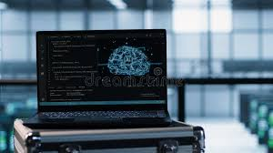

Fig 4.4 LAPTOP BASED SURVER

4.5 I2C SPEAKER AND AMPLIFIER

The I2C amplifier is used to amplify low-power audio signals generated by the controller

or AI server.

The speaker converts these amplified signals into audible sound. This unit is responsible

for voice responses, alerts, and audio feedback.

It ensures clear and loud sound output for effective interaction.

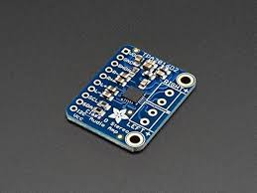

Fig 4.5 I2C AMPLIFIER

An I2C amplifier and speaker system is used in embedded and IoT applications to output sound such as voice, alerts, or educational content. It combines a digital audio amplifier module (controlled via I2C (Inter-Integrated Circuit)) with a speaker to produce audible sound.
An I2C amplifier is an audio amplifier module that can be configured and controlled using I2C communication. It amplifies low-level audio signals from a microcontroller and sends them to a speaker.
Unlike traditional amplifiers, it allows:
- Volume control through software
- Power management via registers
- Easy integration with microcontrollers like Arduino Uno
The I2C amplifier and speaker system provides an efficient way to generate sound in embedded systems. The I2C amplifier and speaker system is an essential component for enabling audio output in embedded systems. Its simple communication, low power consumption, and software-based control make it highly suitable for IoT applications and humanoid robots, especially in educational environments where interactive learning is important.

4.6 DC MOTORS
Brushless DC motors are common in industrial applications across the world. At the most basic level, there are brushed and brushless motors and there are DC and AC motors. Brushless DC motors, as you may imagine, do not contain brushes and use a DC current.
It often helps to explain how a brushed DC motor works first, as they were used for some time before brushless DC motors were available. A brushed DC motor has permanent magnets on the outside of its structure, with a spinning armature on the inside. The permanent magnets, which are stationary on the outside, are called the stator. The armature, which rotates and contains an electromagnet, is called the rotor
In a brushed DC motor, the rotor spins 180-degrees when an electric current is run to the armature. To go any further, the poles of the electromagnet must flip. The brushes, as the rotor spins, make contact with the stator, flipping the magnetic field and allowing the rotor to spin a full 360-degree.
A brushless DC motor is essentially flipped inside out, eliminating the need for brushes to flip the electromagnetic field. In brushless DC motors, the permanent magnets are on the rotor, and the electromagnets are on the stator. A computer then charges the electromagnets in the stator to rotate the rotor a full 360-degree.
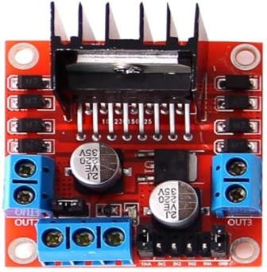

Fig 4.6 DC MOTOR

4.7 WI-FI MODULE
ESP-32 Wi-Fi module is developed by Ai-thinker Team. Core processor ESP8266 in smaller sizes of the module encapsulates Tensilica L106 integrates industry-leading ultra-low power 32-bit MCU micro, with the 16-bit short mode, Clock speed support 80 MHz, 160 MHz, supports the RTOS, integrated Wi- Fi MAC/BB/RF/PA/LNA, on-board antenna.
The module supports standard IEEE802.11 b/g/n agreement, complete TCP/IP protocol stack. Users can use the add modules to an existing device networking, or building a separate network controller.
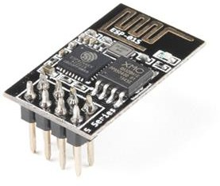
ESP8266 is high integration wireless SOCs, designed for space and power constrained mobile platform designer. It provides unsurpassed ability to embed Wi-Fi capabilities within other systems, or to function as a standalone application, with the lowest cost, and minimal space requirement

Fig 4.7 Wi-Fi Module

FEATURES
- 802.11 b/g/n
- Integrated low power 32-bit MCU
- Integrated 10-bit ADC
- Integrated TCP/IP protocol stack
- Integrated TR switch, balun, LNA, power amplifier and matching network
- Integrated PLL, regulators, and power management units
- Supports antenna diversity
- Wi-Fi 2.4 GHz, support WPA/WPA2
- Support STA/AP/STA+AP operation modes
- Support Smart Link Function for both Android and iOS devices
- Support Smart Link Function for both Android and iOS devices
- SDIO 2.0, (H) SPI, UART, I2C, I2S, IRDA, PWM, GPIO
- STBC, 1x1 MIMO, 2x1 MIMO
- A-MPDU & A-MSDU aggregation and 0.4s guard interval
- Deep sleep power < 5Ua
- Wake up and transmit packets in < 2ms
- Standby power consumption of < 1.0mW (DTIM3)
• +20dBm output power in 802.11b mode.
- Operating temperature range -40C ~ 125

4.8 ULTRASONIC SENSORS

- The ultrasonic sensor is used to measure distance and detect obstacles.
- It works by transmitting ultrasonic sound waves and receiving the reflected echo.
- Based on the time delay, the distance of an object is calculated.
- This sensor is commonly used for obstacle detection, safety systems, and navigation
purposes.
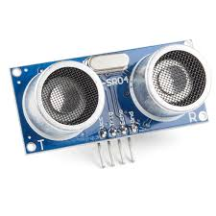
Fig 4.8 ULTRASONIC SENSOR

An ultrasonic sensor works based on the principle of Ultrasonic Sound Waves, which are sound waves with frequencies higher than the human hearing range (above 20 kHz). The sensor emits these waves and detects their reflection from objects.
A commonly used module in projects is the HC-SR04 Ultrasonic Sensor.
Features
- Non-contact distance measurement
- High accuracy and reliability
- Simple interface with microcontrollers
- Low power consumption
- Works in various lighting conditions
SPECIFICATIONS
- Operating Voltage: 5V DC
- Operating Current: 15mA
- Working Frequency: 40kHz
- Max Range: 400cm-450cm
- Min Range: 2cm
- Measuring Angle: < 15°
- Resolution: 0.3cm
- Trigger Input Signal: 10µs TTL pulse
- Echo Output Signal: TTL lever signal (proportional to range)
- Dimensions: 45mm x 20mm x 15mm
4.9 ESP32 CAM

- ESP32-CAM is a compact module that combines a camera with an ESP32 microcontroller.
- It is used to capture images and video data. This module supports image processing tasks
such as face detection and monitoring.
- It is widely used in surveillance, security, and smart vision applications.
The ESP32-CAM is a low-cost microcontroller module with an integrated camera and Wi-Fi/Bluetooth
connectivity. It is widely used in IoT, surveillance systems, and smart robotics for capturing and transmitting
images or video. It is based on the powerful ESP32 chip, which supports wireless communication and real-
time processing.
Features
- Built-in OV2640 camera module
- Wi-Fi and Bluetooth connectivity
- Supports image capture and video streaming
- MicroSD card slot for storage
- Low power consumption
- Compact size and low cost
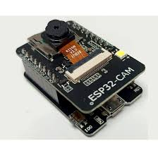
Fig 4.9 ESP32 CAM

Specifications

Operating Voltage: 5V

Microcontroller: ESP32 (32-bit dual-core processor)

Camera: OV2640 (2MP)

Wi-Fi: 802.11 b/g/n

Bluetooth: BLE supported

RAM: 520 KB SRAM + external PSRAM (optional)

Flash Memory: 4 MB

Interfaces: UART, SPI, I2C, PWM

Storage: MicroSD card support (up to 32GB)

CHAPTER 5

SOFTWARE COMPONENTS

ARDUINO SOFTWARE

    - PROGRAMMING

Step 1: Installing the Firmware

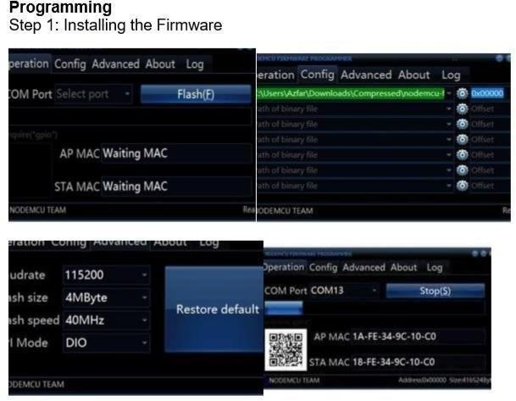
Fig 5. 1 Installation of the Firmware

In Node MCU Boards the first thing you need is to install the Firmware to the board the following method works for all Node MCU Boards
      - Open the Esp32flasher master folder than open the win32/win64 folder as your computer. Now open the folder Release than double click Esp32Flasher.
      - Select the COM Port.
      - Go to configure tab.

      - Click on the small gear and open up the firmware which you have downloaded.
      - Go to the advanced tab and select the desired Baud rate.
      - Go to the Operation tab and click on Flash Button. Add Tip Ask Question Comment Download

Step 2: Preparing the Arduino IDE

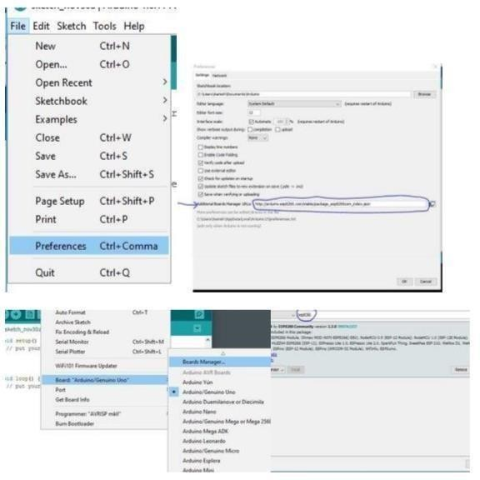
Fig 5. 2 Preparation of Arduino IDE

After installing the firmware, you are ready to do the programming with the ESP32

- Install the Arduino IDE
- Open the Arduino IDE from the desktop icon
- Click on File tab and then open preferences
- In the additional Boards Manager URLs add the following link (http://arduino.esp32.com/stable/package_esp32com_index.json) and click OK
- Go to Tools>Boards>Boards Manager
- In the search field type esp32 click the esp32 by ESP32 Community option and click Install
3: Code...

Now we can do whatever you want with your Node MCU board Following is an example for led blinking with Node MCU board via web server
    - In Arduino IDE go to tools>Boards>select (ESP - 12E Module)

    - Again, go to tools and select port.

    - Change the Wi-Fi name and password from the following code.

    - Now click on Upload button to upload the following code.

    - Connect the led's positive leg on D8 pin of board and negative to the ground of the code.

    - Power up the board and open the serial monitor from Arduino IDE

    - After connecting to the Wi-Fi, it will show you the IP address.

    - Type that IP address on the web browser (Edge, Chrome, Firefox etc.,)

    - A webpage will open you can change the status of LED by turning it ON or
OFF.
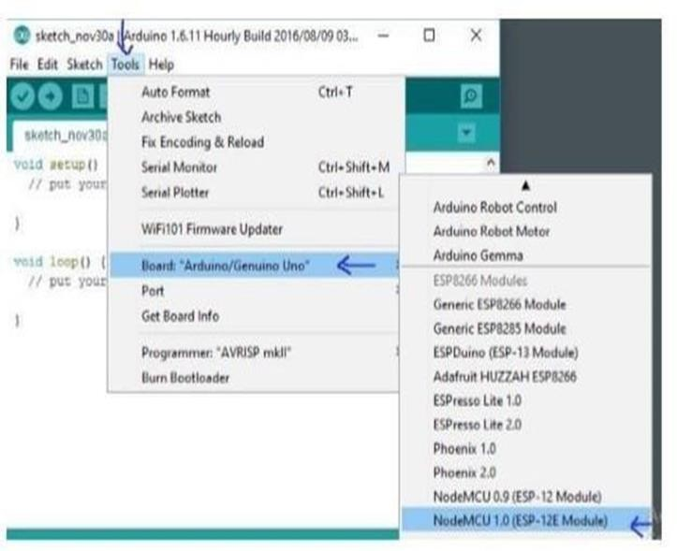

Fig 5. 3 Board Selection

COPY, PASTE AND UPLOAD THE TUTORIAL SKETCH

The sketch is one that comes as an example from ESP32.COM.

Fig 5.4 CODE FOR WI-FI CONNECTION
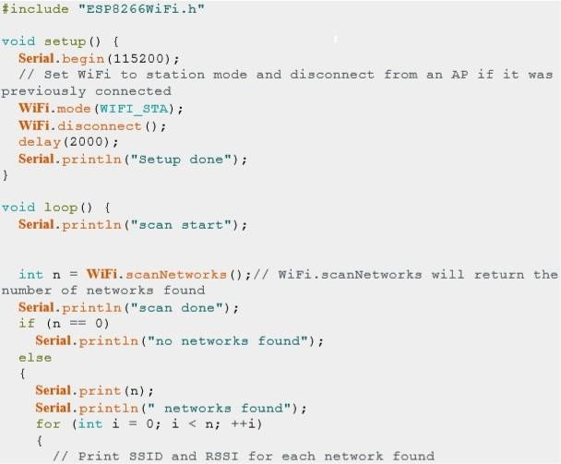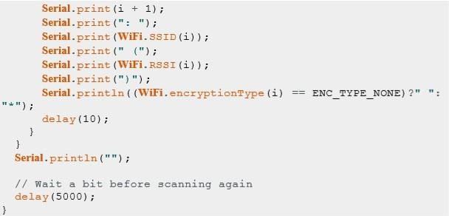

Serial Communication between L239 and Arduino
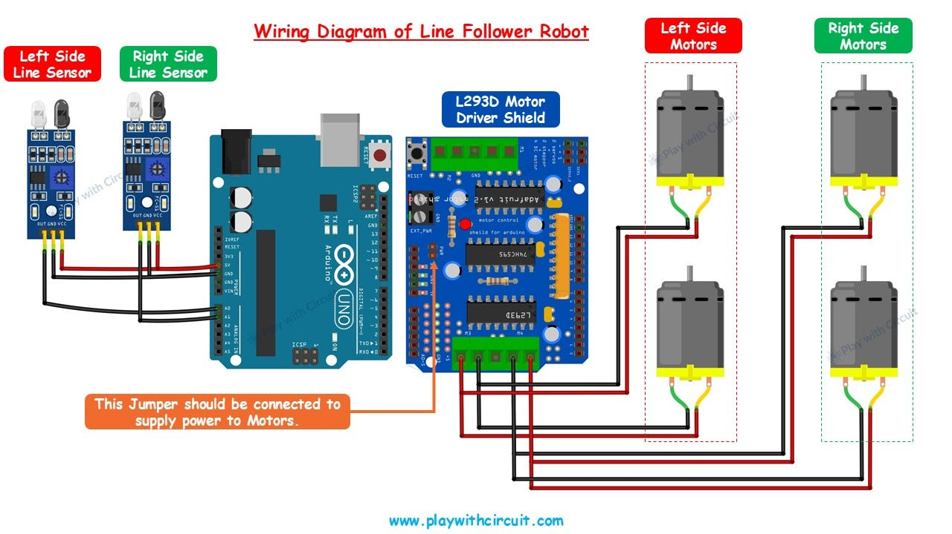

Fig 5. 5 Serial Communication between L239and Arduino

PROJECTS AND APPLICATIONS
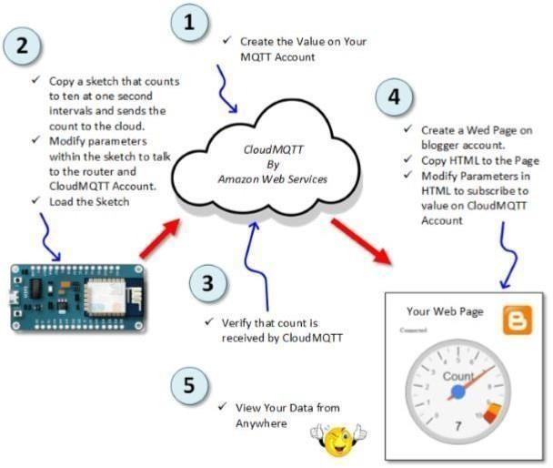
EP32 is mainly used in the Wi-Fi Applications which most of the other embedded modules fail to process unless incorporated with some external Wi-Fi protocol. Following are some major applications used for ESP32
Fig 5. 6 Interaction with AWS

• Internet Controlled Humanoid Robot
• VR-Based Robot Control
• Multi-Legged (Octopod) Robot Control
• Serial Communication and Monitoring System
- Incubator Controller
- IoT home automation
- Security Alarms

Application Example:

ESP32- Arduino IDE Digital Input Tutorial

CONNECT THE CIRCUIT

You may wish to power your ESP32 another way. You can read about it HERE.

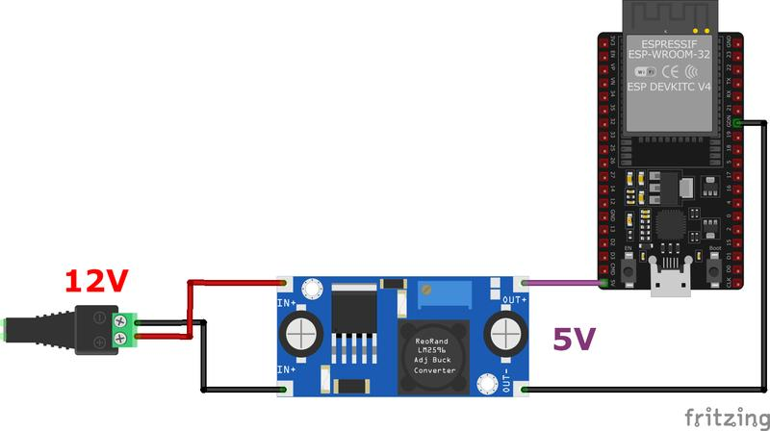

Fig 5. 7 Connections of ESP32

COPY, PASTE AND UPLOAD THE CODE
The code is real simple works as follows:
The input is read from switch pin. If switch is closed, it will read a low.
The LED output pin is set to the opposite of the switch pin. If the switch is closed, the output pin will be set to a high. A high will turn on the LED.
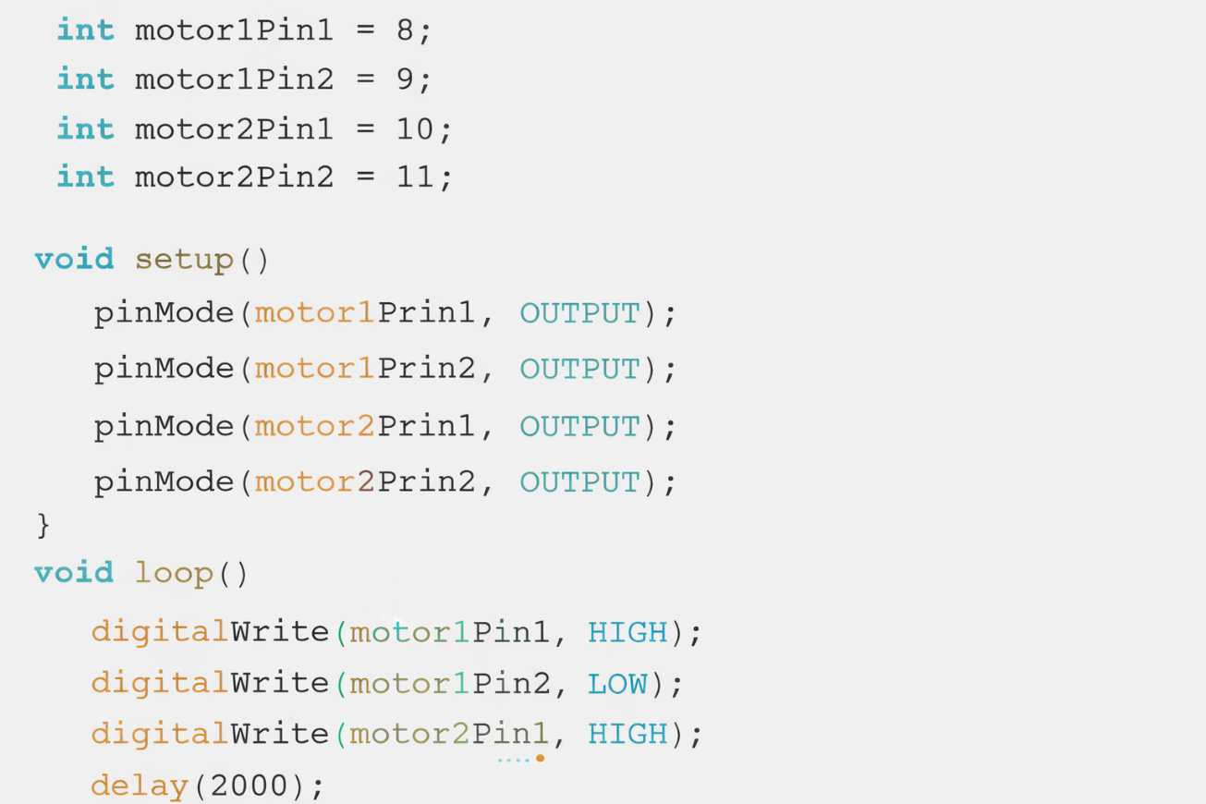

Fig 5. 8 Code for LED blinking

  - PROTEUS

INTRODUCTION:
Generally, we are listening the words PCB’s, PCB layout, PCB designing, etc. Why we are using this PCB? We want to know about all these things as an electronic engineer. PCB means Printed Circuit Board. This is a circuit board with printed copper layout connections. These PCBs are two types. One is dotted PCB and another one is layout PCB. The two examples are shown in below.


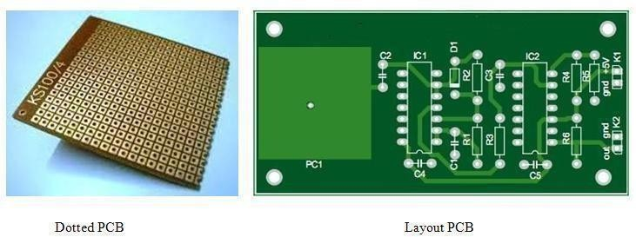

Fig 5.9 Dotted PCB and Layout PCB

In dotted PCB board only, dots are available. According to our requirement we can place or insert the components in those holes and attach the components with wires and soldering lid. In this dotted PCB we can make the circuit as out wish but it is very hard to design. There are so many difficulties are there. Those are connecting the proper pins, avoiding shot connections and etc. Coming to the layout PCB this is simple to design. First, we select our circuit and by using different PCB designing software’s, design the layout of the circuit and by itching process preparing the copper layout of our circuit and solder the components in the correct places. It is simple to design, take less time to design, no shortages, looking nice and perfect.
Up to now we have discussed about types of PCB’s and difference between the types. Now we can discuss about PCB designing software. There are so many PCB designing software’s available. Some are Express PCB, eagle PCB, PCB Elegance, free PCB, open circuit design, zenith PCB and Proteus etc.
Apart from remaining Proteus is different. Proteus is design suit and PCB layout designing software. In Proteus we can design any circuit and simulate the circuit and make PCB layout for that circuit.

Introduction to Proteus:
Proteus professional is a software combination of ISIS schematic capture program and ARES PCB layout program. This is a powerful and integrated development environment. Tools in this suit are very easy to use and these tools are very useful in education and professional PCB designing.
As professional PCB designing software with integrated space based auto router, it the curser at the component pin end then draw the connections with that pen symbol. Connect all the components according to circuit then that designed circuit is show in below image.

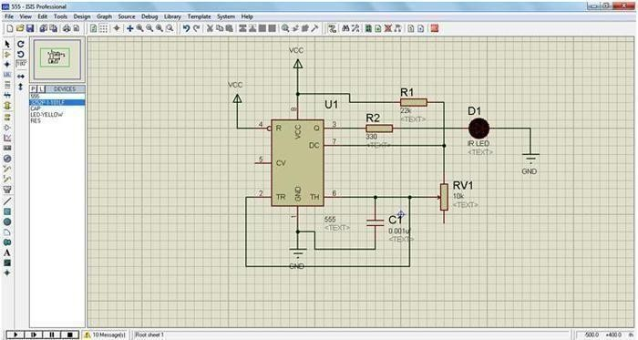
Fig 5. 10 Schematic Representation

If any modifications want to do to the component place the mouse point and click on right button then option window will open. That is shown in below figure.
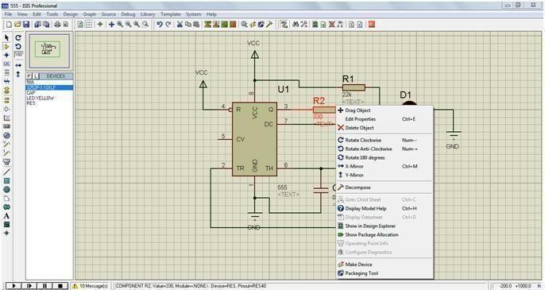
After completion of designing save with some mane and debug it. This is virtual simulation means without making circuit we can see the result in virtually through this software and we can design the PCB layout to our required circuit with this software.

Fig 5. 11 PCB Layout

CHAPTER 6

RESULT AND DISCUSSION
6.1 RESULT:
The developed humanoid robot for children education using embedded systems and IoT was successfully designed and tested. The system demonstrated effective interaction with children by providing audio-based learning, basic question–answer responses, and real-time feedback.
The robot was able to:
- Recognize simple inputs and respond appropriately
- Deliver educational content such as alphabets, numbers, and basic instructions
- Provide voice output using speaker modules
- Connect to IoT platforms for remote monitoring and content updates
- Operate with stable performance under normal conditions
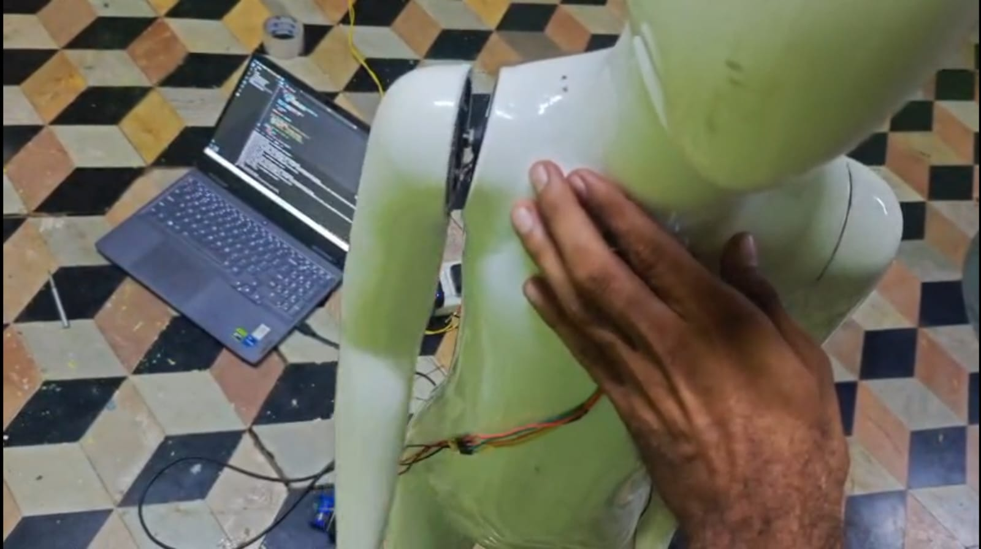
The integration of embedded hardware and IoT technology ensured that the robot functioned efficiently with low response time and minimal power consumption. The system showed reliable communication between components such as sensors, microcontroller, and output devices.

Fig 6.1(a)
6.2 DISCUSSION:
The results indicate that the humanoid robot significantly enhances the learning experience of children by making education more interactive and engaging. Compared to traditional teaching methods, the robot provides:
- Personalized learning support by responding to individual queries
- Continuous availability, enabling learning at any time
- Improved attention and curiosity among children through interactive communication
The use of IoT enables real-time updates and monitoring, allowing teachers or parents to track progress and modify educational content remotely. This adds flexibility and scalability to the system. However, certain limitations were observed:
- The robot handles only basic-level interactions and limited vocabulary
- Performance depends on network connectivity for IoT features
- Audio quality and speech recognition accuracy can vary
- Initial setup and programming require technical knowledge.
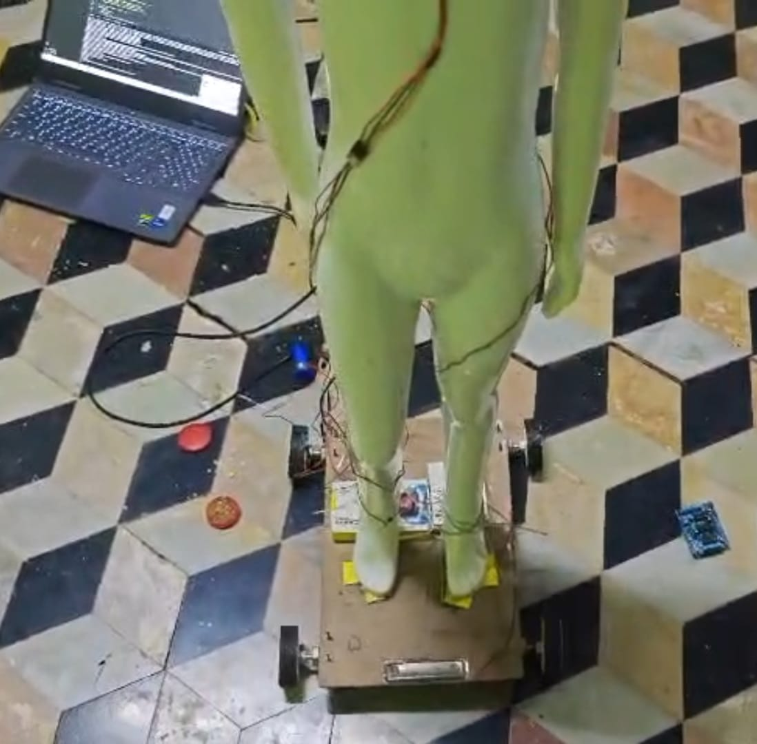
Fig 6.1 (b) Physical Design of Humanoid Robot

CHAPTER 7

ADVANTAGES AND APPLICATIONS
7.1ADVANTAGES
- Personalized Learning: Robots can adapt lessons based on each child’s learning speed and understanding level.
- 24/7 Learning Support: With embedded systems and IoT connectivity, robots can assist
students anytime, anywhere.
- Interactive Teaching: Humanoid robots use voice, gestures, and expressions to make learning more engaging and fun.
- Improved Student Engagement: Children show more interest and curiosity when learning
with robots compared to traditional methods.
- Instant Feedback and Doubt Clarification: Robots can immediately respond to questions
and correct mistakes in real-time.
- Remote Learning Capability: IoT enables teachers to monitor and guide students remotely through the robot.
- Consistent Teaching Quality: Robots deliver the same quality of teaching without fatigue
or variation.
- Development of Social Skills: Interaction with humanoid robots helps children improve communication and confidence.
- Multilingual Support: Robots can be programmed to teach in multiple languages, helping
diverse learners.
- Data Collection and Performance Analysis: IoT allows tracking of student progress and learning patterns for better evaluation.
- Safe Learning Environment: Robots provide a controlled and patient teaching environment without human bias.

7.2 APPLICATION

1. Interactive Teaching Assistance: Humanoid robots act as interactive teaching assistants

in classrooms. Using embedded systems, they process voice commands and respond instantly,

while IoT connects them to cloud-based learning platforms. They can explain subjects like

alphabets, numbers, and basic science in a fun and engaging way.

2. Language Learning and Communication Skills: Humanoid robots help children improve

Language and communication skills. With embedded speech recognition systems and IoT-based

language databases, robots can: Teach pronunciation, conduct conversations, Correct mistakes

in real time, this is especially useful for learning English or other languages in a natural

conversational way.

3. Personalized Learning Experience: Using IoT connectivity, robots collect and analyze student

data to provide personalized learning. Embedded processors track: Learning speed, Mistakes, Interest

areas based on this data, the robot adjusts lesson difficulty and teaching style, ensuring each child

learns at their own pace.

4. Special Education Support: Humanoid robots are very helpful in special education, especially

for children with autism or learning disabilities. They provide: Consistent interaction,

Simple communication pattern. Emotional comfort Embedded sensors detect responses, and IoT

Allows therapists to monitor progress remotely.

5. Remote Learning and Smart Classrooms: With IoT integration, humanoid robots support

remote education. They can: Connect to online classes, Stream lessons, Interact with teachers

remotely. This is useful in rural or remote areas where quality education access is limited.

6.STEM Education and Practical Learning: Humanoid robots promote STEM (Science,

Technology, English, Mathematics) learning. Children can: Learn basic coding, understand

robotics concepts, perform simple experiments Embedded systems help demonstrate real-time

functioning, while IoT provides access to updated educational content.

7. Social Skill Development: Robots help children develop social and behavioral skills. They can

teach: Greetings and manners, Emotional expressions, Teamwork activities, through repeated

interaction, children become more confident in communication.

8.Storytelling and Creative Learning: Robots enhance creativity through storytelling and role-

playing. They use gestures, voice modulation, and expressions to narrate stories, making learning

more imaginative and engaging.

CHAPTER 8

CONCLUSION AND FUTURE SCOPE

CONCLUSION

This Project has proposed a framework that addresses an under-researched and not well- understood
aspect of humanoid robots. Rapid technological progress in robots needs to be balanced with a holistic
Approach to research that attempts to support human adaptation in rapidly changing socio-technical
system dynamics. With such a multidisciplinary framework, we offer the possibility to move beyond
extending the technical possibilities to evaluating how technological advancements can be used in an
ethical way to benefit individuals and society through education.
In particular, the multidisciplinary framework presented here integrates the technological,
pedagogical, psycho-social and ethical aspects of HRI. Further, this paper has presented a possible
way to apply and evaluate the framework, methodologically, along with an example of a case study.
It is hoped that readers will be inspired to adopt this interdisciplinary framework as them
Starting point for research into how humanoid robots can be used effectively in and contribute
to the development of the research base within this field.
Although this study includes concrete suggestions regarding the application and evaluation of the
proposed interdisciplinary framework along with a case study describing its application in a real
setting with a focus on learning mathematical and programming.
Although humanoid robots are currently very far away from being autonomously situated in
pre- primary and primary schools because of technological limitations such as emotion recognition
and inaccurate speech, they can be used in classrooms as learning tools since they have the ability to
provide real-time feedback to students.

8.2 FUTURESCOPE

1. Advanced AI Integration
In the future, humanoid robots can be equipped with powerful Artificial Intelligence algorithms
That enable adaptive learning. The robot can observe a child’s performance, identify strengths and
weaknesses, and modify the teaching content accordingly.
2. Voice Recognition & Natural Language Processing
Future robots will use advanced speech recognition and Natural Language Processing (NLP)
to understand children's questions more accurately. Unlike basic command-based systems, these
robots can carry out meaningful conversations, answer doubts, and explain concepts in a human-
like manner. This improves communication skills in children and makes learning more interactive
and engaging.
3. Cloud-Based Learning via IoT
With the help of IoT technology, humanoid robots can be connected to cloud platforms were
educational content is stored and continuously updated. Teachers can upload lessons, assignments,
and quizzes remotely. Parents and educators can monitor the child’s progress in real-time through
mobile or web applications.
This ensures that the robot always has access to the latest and most relevant educational materials.
4. Emotion Recognition System
Future humanoid robots may include cameras and sensors that detect facial expressions and body
language to understand a child’s emotional state. For instance, if a child appears confused or frustrated,
the robot can slow down the lesson or provide encouragement.
This emotional intelligence can create a supportive learning environment, similar to human teachers, improving the overall educational experience.
5. Multi-Language Support
Humanoid robots can be enhanced to support multiple languages, allowing children from different
linguistic backgrounds to learn comfortably. The robot can switch between languages based on user
preference and even help children learn new languages through interactive conversations and exercises.
This feature is especially useful in multilingual countries like India.

6. Augmented Reality (AR) and Virtual Reality (VR) Integration
Incorporating AR and VR technologies with humanoid robots can transform traditional learning
into immersive experiences. For example, a robot can guide a child through a virtual tour of the solar
system or demonstrate scientific experiments in a 3D environment. This enhances understanding of
complex subjects and increases student engagement.

7. Remote Education & Smart Classrooms
Humanoid robots can play a significant role in remote education by acting as virtual teachers
in areas where human teachers are not available.
Through IoT connectivity, these robots can connect to centralized teaching systems and deliver
lecture, conduct tests, and interact with students. This helps bridge the educational gap between
urban and rural regions.
8. Improved Hardware and Cost Reduction
Advancements in embedded systems and electronics will lead to smaller, faster, and more
energy-efficient components. As technology becomes more affordable, the cost of humanoid robots
will decrease, making them accessible to schools, especially in developing regions. Improved battery
life and compact design will also enhance usability.

9. Gamification of Learning
Future humanoid robots can include gamified learning techniques such as quizzes, puzzles, rewards,
and challenges. These elements make education more enjoyable and motivate children to actively
participate in learning. The robot can track progress and provide rewards or encouragement, creating
a fun and competitive learning atmosphere.

10. Integration with Wearable Devices
Humanoid robots can be integrated with wearable devices like smart watches or fitness
bands to monitor children’s physical and mental health. These devices can track parameters such as
heart rate, activity level, and attention span. Based on this data, the robot can adjust learning sessions,
suggest breaks, or introduce physical activities to maintain a healthy balance.

REFERENCES

[1]. Sharkey, A. J. (2016). Should we welcome robot teachers? Ethics and Information Technology,
18(4), 283-297.

[2]. Bargagna, Stefania, et al. "Educational robotics in down syndrome: a feasibility study."
Technology, knowledge and learning 24 (2019): 315-323. https://doi.org/10.1007/s10758-018-9366-z

[3] Alimisis, Dimitris. "Educational robotics: Open questions and new challenges."
Themes in Science and Technology Education 6.1 (2013): 63-71.

[4] Zawieska, Karolina, and Brian R. Duffy. "The social construction of creativity in educational
robotics." Progress in Automation, Robotics and Measuring Techniques: Volume 2 Robotics.
Springer International Publishing, 2015

[5]. Pennisi, Paola, et al. "Autism and social robotics: A systematic review." Autism Research 9.2
(2016): 165-183. https://doi.org/10.1002/aur.1527

[6]. Robins, Ben, et al. "Scenarios of robot-assisted play for children with cognitive and physical
disabilities." Interaction Studies 13.2 (2012): https://doi.org/10.1075/is.13.2.03rob 189-234.

[7]. Conchinha, Cristina, Patrícia Osório, and João Correia de Freitas. "Playful learning: Educational
robotics applied to students with learning disabilities." 2015 International symposium on
computers in education (SIIE). IEEE, 2015. https://doi.org/10.1109/SIIE.2015.7451669

[8]. Xia, Liying, and Baichang Zhong. "A systematic review on teaching and learning robotics
content knowledge in K-12." Computers & Education 127 (2018):
267-282 https://doi.org/10.1016/j.compedu.2018.09.007

[9]. Tuna, G., Tuna, A., Ahmetoglu, E. & Kuscu, H. (2019). A survey on the use of humanoid robots in primary education.

[10]. Bartneck C, Alnajjar F, Baxter P, Belpaeme T, Cappuccio M, Di Dio C, Eyssel F,
Handke J, Mubin, O Obaid, M & Reich-Stiebert N (2021) Robots in education: An introduction to
high-tech social agents, intelligent tutors, and curricular tools. Routledge. https://doi.org/10.4324/9781003142706

[11]. Belpaeme T, Kennedy J, Ramachandran A, Scassellati B, Tanaka F (2018) Social
robots for education: a review. Sci Robot 3(21): eaat5954. https://doi.org/10.
1126/scirobotics.aat5954

[12]. Woo H, LeTendre GK, Pham-Shouse T, Xiong Y (2021) The use of social robots in
classrooms: A review of field-based studies. Educ Res Rev 33:100388. https://
doi.org/10.1016/j.edurev.2021.100388

[13]. Velentza A-M, Fachantidis N, Lefkos I (2022) Human-robot interaction methodology:
Robot teaching activity. MethodsX 9:101866. https://doi.org/10.1016/
j.mex.2022.101866

[14]. Langer A, Marshall PJ, Levy-Tzedek S (2023) Ethical considerations in child-robot
interactions. Neurosci Biobehav Rev 151:105230. https://doi.org/10.1016/j.
neubiorev.2023.105230

[15]. Kim Y, Hwang J, Lim S, Cho M-H, Lee S (2023) Child–robot interaction: designing
robot mediation to facilitate friendship behaviors. Interactive Learning
Environments. https://doi.org/10.1080/10494820.2023.2194936

[16]. Kanero J, Geçkin V, Oranç C, Mamus E, Küntay AC, Göksun T (2018) Social
robots for early language learning: Current evidence and future directions.
Child Dev Perspect 12(3):146–151. https://doi.org/10.1111/cdep.12277

[17]. Jones A, Bull S, Castellano G (2017) I know that now, I’m going to learn this next”:
Promoting self-regulated learning with a robotic tutor. Int J Soc Robot
10(4):439–454. https://doi.org/10.1007/s12369-017-0430-y

[18]. Esfandbod A, Rokhi Z, Meghdari AF, Taheri A, Soleymani Z, Alemi M, Karimi M
(2023) Fast mapping in word-learning: a case study on the humanoid social
robots’ impacts on children’s performance. Int J Child Compute Interact 38:
100614. https://doi.org/10.1016/j.ijcci.2023.100614

[19]. Alnajjar, F., Hafiz, A. R. & Murase, K. (2010). HCBPM: An Idea toward a Social Learning Environment for
Humanoid Robot. Journal of Robotics, 2010, Article ID 241785. doi:10.1155/2010/241785

[20]. Tanaka F, Cicourel A, and Movellan JR (2007). Socialization
between toddlers and robots at an early childhood education
center. Proceedings of the National Academy of Sciences,
104(46): 17954-17958.

APPENDIX

# =========================================================
# HUMANOID AI VOICE INTERACTION SYSTEM (DOC)
# =========================================================

# ================= IMPORTS =================
import socket
import threading
import time
import random
import json

# ================= CONFIG =================
CONFIG = {
"mic_ip": "192.168.0.101",
"speaker_ip": "192.168.0.102",
"mic_port": 3333,
"speaker_port": 4444,
"model": "NeuroCore-AI-v2",
"language": "en"
}

# ================= STATES =================
STATE_IDLE = "IDLE"
STATE_LISTEN = "LISTEN"
STATE_PROCESS = "PROCESS"
STATE_DECIDE = "DECIDE"
STATE_ACTION = "ACTION"
STATE_SPEAK = "SPEAK"

current_state = STATE_IDLE

# ================= DEVICE CONNECTION =================
class DeviceManager:

def __init__(self):
self.mic_connected = False
self.speaker_connected = False

def connect_all(self):
print("🔌 Initializing device connections...")
time.sleep(1)

self.mic_connected = True
self.speaker_connected = True

print("✅ Microphone ESP Connected")
print("✅ Speaker ESP Connected")

device_manager = DeviceManager()

# ================= AUDIO MODULE =================
class AudioModule:

def capture_stream(self):
print("🎙️ Capturing voice stream...")
time.sleep(1)

# Dummy simulated input
samples = ["hi", "hello system", "status check", "run command"]
return random.choice(samples)

audio_module = AudioModule()

# ================= AI ENGINE =================
class AIEngine:

def __init__(self, model):
self.model = model

def preprocess(self, text):
print("🔍 Preprocessing input...")
time.sleep(0.5)
return text.lower().strip()

def inference(self, text):
print("🧠 Running inference on model:", self.model)
time.sleep(1.5)

# Dummy decision logic
if "hi" in text:
return {"intent": "greet", "confidence": 0.95}
elif "status" in text:
return {"intent": "status_check", "confidence": 0.90}
else:
return {"intent": "general_query", "confidence": 0.80}

def generate_response(self, intent):
print("🧾 Generating response...")
time.sleep(1)

responses = {
"greet": "Hello! I am ready to assist you.",
"status_check": "All systems are functioning normally.",
"general_query": "Processing your request."
}

return responses.get(intent, "Unknown command.")

ai_engine = AIEngine(CONFIG["model"])

# ================= ACTION MODULE =================
class ActionModule:

def trigger_servo(self):
print("🤖 Activating servo gesture...")
time.sleep(0.5)

def trigger_led(self):
print("💡 LED indication ON")
time.sleep(0.3)

def execute(self, intent):

print("⚙️ Executing action for intent:", intent)

if intent == "greet":
self.trigger_servo()
elif intent == "status_check":
self.trigger_led()

action_module = ActionModule()

# ================= SPEAKER MODULE =================
class SpeakerModule:

def send_audio(self, text):
print("🔊 Converting text to speech...")
time.sleep(1)

print("📡 Streaming audio to ESP speaker...")
time.sleep(1)

print("🗣️ OUTPUT:", text)

speaker_module = SpeakerModule()

# ================= LOGGER =================
class SystemLogger:

def log_event(self, event):
timestamp = time.strftime("%H:%M:%S")
print(f"[{timestamp}] {event}")

logger = SystemLogger()

# ================= MAIN CONTROLLER =================
class HumanoidController:

def __init__(self):
self.state = STATE_IDLE

def run(self):

global current_state

device_manager.connect_all()
self.state = STATE_LISTEN

while True:

logger.log_event(f"Current State: {self.state}")

# ===== LISTEN =====
if self.state == STATE_LISTEN:

voice = audio_module.capture_stream()
logger.log_event(f"Input Captured: {voice}")

self.state = STATE_PROCESS

# ===== PROCESS =====
elif self.state == STATE_PROCESS:

clean_text = ai_engine.preprocess(voice)
result = ai_engine.inference(clean_text)

intent = result["intent"]
confidence = result["confidence"]

logger.log_event(f"Intent: {intent}, Confidence: {confidence}")

self.state = STATE_DECIDE

# ===== DECIDE =====
elif self.state == STATE_DECIDE:

if confidence > 0.7:
self.state = STATE_ACTION
else:
self.state = STATE_SPEAK

# ===== ACTION =====
elif self.state == STATE_ACTION:

action_module.execute(intent)
self.state = STATE_SPEAK

# ===== SPEAK =====
elif self.state == STATE_SPEAK:

response = ai_engine.generate_response(intent)
speaker_module.send_audio(response)

self.state = STATE_LISTEN

time.sleep(1)

# ================= SYSTEM START =================
if __name__ == "__main__":

print("🤖 HUMANOID AI SYSTEM BOOTING...")
print("📡 Initializing subsystems...")
time.sleep(2)

controller = HumanoidController()
controller.run()

